

SCHOOL OF COMPUTING AND INFORMATICS

BACHELOR OF SCIENCE IN COMPUTER SCIENCE

UNIT CODE: BIT4138

UNIT NAME: ADVANCED CRYPTOGRAPHY

PROJECT TITLE: SECURE FILE ENCRYPTION SYSTEM

WEEK 1-5 SUMMARY

GITHUB LINK
https://github.com/xoashlyyy/BIT4138-Advanced-Cryptography

NAME | REG. NO
ASHLEY JOY ONYANGO | BSCCS/2024/50264

LECTURER: Mr. MICHAEL NYORO
SUBMISSION DATE: 08/06/2026

Contents
Week 1: Cryptography Environment Setup 6
Week 2: Classical Cryptography and Cipher Design 8
Week 3: Stream Ciphers and Randomness Testing 12
Week 4: Block Cipher Design and AES 13
Week 5: Public Key Cryptography (RSA) 15
Creative Project: Interactive Crypto Vault Dashboard 16
Week 6 18
Task 1: Basic SPN Design & Implementation 18
Practical Task 2: Non-Linearity Investigation 19
1. What is Non-Linearity in Cryptography? 19
2. Why is Non-Linearity Critically Important? 20
3. How S-Boxes Create Non-Linearity 20
Practical Task 3: SPN vs. Feistel Structure Security Evaluation 20
1. Architectural Comparison 20
2. Evaluation Matrix 21
Advanced programming task 22
Challenge task 23
Security Analysis Report: Advanced Multi-Round SPN 25
Week 7 26
Task 1: Differential Cryptanalysis Simulation 26
Task 2: Block Cipher Security Breach 27
IN-DEPTH ANALYSIS OF MODERN CRYPTANALYSIS 27
Conclusion 29
Task 3: Security Evaluation of AES 29
1. Why AES is Resistant to Differential Cryptanalysis 29
2. Why AES is Resistant to Linear Cryptanalysis 29
3. Modern Research Findings on AES Security 30
Conclusion 30
Advanced Programming Task 30
Challenge task 33
WEEK 8 35
Practical Task: OpenSSL Certificate Inspection 35
DIGITAL CERTIFICATE SECURITY INCIDENT REPORT 37
WEEK 9 38
Individual assignment 38
Real-World Uses of the RSA Cryptosystem: Securing the Web with SSL/TLS (HTTPS) 40
Introduction 40
How RSA Powers the SSL/TLS Handshake 41
The Security Paradigm and Challenges 41
Conclusion 41
WEEK 10: ElGamal Cryptosystem and Elliptic Curve Cryptography 46
Creative Challenge 48
Mini Project Extension: Cryptographic Architecture Evaluation 50
1. Executive Summary 50
2. Comparative Analysis 51
3. Suitability for Target Applications 51
4. Final Recommendation 51

List of Figures
Figure 1: Installation of Python and VS Code 6
Figure 2: : Installation of Cryptography Libraries 7
Figure 3: OpenSSL Installation Test 7
Figure 4: Local Encryption Python Script 7
Figure 5: Local Encryption Script Execution 7
Figure 6: GitHub Repository Initialization 8
Figure 7: Caesar Cipher & Vigenère Cipher Python Script 9
Figure 8: Encryption and Decryption Output 10
Figure 9: User Input Validation Python Script 10
Figure 10: User Input Validation Output 11
Figure 11: LFSR Generator Implementation Python Code 12
Figure 12: Pseudorandom Sequence Output 12
Figure 13: Statistical Randomness Testing 13
Figure 14: Encryption Performance Python Code 13
Figure 15: Encryption Performance Results 13
Figure 16: AES Encryption Python Script 13
Figure 17: Key Generation Process 14
Figure 18: Encryption process 14
Figure 19: Decryption Process 14
Figure 20: File Encryption & Decryption Results 14
Figure 21: RSA Key Pair Generation 15
Figure 22: Public Key Encryption Process 15
Figure 23: Private Key Decryption Process 15
Figure 24: Secure Message Transmission 15
Figure 25: Message Decryption 15
Figure 26: Requirements Installation(CP) 16
Figure 27: Interface Architecture 17
Figure 28: Backend Integration 17
Figure 29: Interactive Encryptor 18
Figure 30: S-Box Dictionary Mapping for the Substitution (Confusion) Layer 18
Figure 31: P-Box Logic utilizing Block Reversal for the Permutation (Diffusion) Layer 19
Figure 32: Terminal Output demonstrating the Step-by-Step SPN Encryption Transformation 19
Figure 33: Multi-Round SPN Execution Framework 22
Figure 34: Implementation of Non-Linear Substitution (S-Box) and Linear Permutation Layers 22
Figure 35: Corrected Key Mixing Logic Utilizing Bitwise XOR 22
Figure 36: User Execution Logic and Avalanche Effect Mathematical Calculation 23
Figure 37: Successful Execution of Multi-Round SPN and Avalanche Effect Demonstration 23
Figure 38: Bitwise XOR Key Mixing Implementation 23
Figure 39: S-Box Substitution and Block Reversal Permutation Functions 23
Figure 40: Multi-Round SPN Execution Framework 24
Figure 41: Streamlit Graphical Interface Input Configuration 24
Figure 42: Event Trigger and Avalanche Effect Calculation Logic 24
Figure 43: Streamlit Web Dashboard Demonstrating the Advanced Multi-Round SPN Implementation 24
Figure 44: Implementation of Plaintext Input Acceptance and Binary Conversion 26
Figure 45: Computation Logic for Bitwise XOR Differences and Percentage Calculation 26
Figure 46: Execution Output for Differential Observations and Final Analytical Conclusion 26
Figure 47: Python script simulation calculating the differential variance and XOR difference map for the plaintext "ASHLEY". 27
Figure 48: Input Difference Analysis and String Padding Logic 30
Figure 49: Frequency Analysis Implementation using collections.Counter 31
Figure 50: Statistical Bias Variance Calculation Algorithm 31
Figure 51: User Input Acceptance and Automatic Toolkit Execution Logic 31
Figure 52: Complete Terminal Output of the Mini Cryptanalysis Toolkit Demonstrating Difference, Frequency, and Statistical Bias Analysis 32
Figure 53: Core Difference Calculation and Avalanche Percentage Logic 33
Figure 54: Binary Conversion and Avalanche Metric UI Implementation 33
Figure 55: Character Frequency DataFrame and Bar Chart Generation 33
Figure 56: Statistical Data Dictionary and UI Table Rendering 33
Figure 57: Security Analyzer Dashboard Displaying Input Parameters and Frequency Visualization 34
Figure 58: Security Analyzer Dashboard Displaying Avalanche Metrics and CSV Export Interface 34
Figure 59: Successful Download of the PEM Certificate into the Project Directory 35
Figure 60: OpenSSL Inspection Displaying Certificate Issuer, Subject, and Expiry Date 35
Figure 61: OpenSSL Output Detailing Subject Alternative Names (SAN) and Extensions 36
Figure 62: OpenSSL Output Verifying the ECDSA Signature Algorithm and Hexadecimal Value 36
Figure 63 (Key Generation output): Execution of ElGamal Cryptosystem and 512-bit Key Generation 38
Figure 64(Processing 5 messages): Successful Encryption, Decryption, and Verification of Five Unique Messages 39
Figure 65(k-Reuse explanation): Terminal Output Explaining the Security Necessity of the Ephemeral Key (k) in ElGamal 40
Figure 66 (Option 1 - Key Generation): Generation of 512-bit RSA Public and Private Keys 42
Figure 67(Option 2 - Encryption): RSA Encryption of Plaintext into ASCII and Ciphertext Arrays 42
Figure 68(Option 3 - Decryption): RSA Decryption Process Reverting Ciphertext to Original Plaintext 43
Figure 69 (Option 4 - Sign Message): Generating an RSA Digital Signature via SHA-256 Hashing 43
Figure 70 (Option 5 - Verify Signature): Successful Cryptographic Verification of the RSA Digital Signature 44
Figure 71 (Option 6 - Miller-Rabin): Execution of the Miller-Rabin Primality Test on Random Integers 44
Figure 72 (Option 7 - Pollard Rho): Pollard's Rho Factorization Demonstrating the Vulnerability of Small Moduli 45
Figure 73 (Option 8 - Secure Chat): RSA Secure Chat Simulation Demonstrating End-to-End Encrypted Message Exchange 45
Figure 74(Key Generation): ElGamal Key Generation Displaying Prime, Generator, and Key Pairs 46
Figure 75 (Encryption): ElGamal Message Encryption Showing the Ephemeral Key and Ciphertext Pair 46
Figure 76 (Decryption): Successful Decryption of the ElGamal Ciphertext to the Original Plaintext 46
Figure 77 (Randomness & Benchmark): Randomness Demonstration and Execution Time Benchmarking for RSA vs. ElGamal 47
Figure 78 (ECC Demo): Elliptic Curve Cryptography (ECC) Demonstration Showcasing Key Generation and Signature Verification 47
Figure 79 (The active chat screen): Secure University Messenger Chat Interface Displaying Messages and Digital Signatures 48
Figure 80 (The login screen): Secure University Messenger Role-Based Login Interface 49
Figure 81 (The save dialog box): Secure Chat History Export Functionality to Local Text File 50

Week 1: Cryptography Environment Setup
Installation and Configuration of Cryptography Development Environment
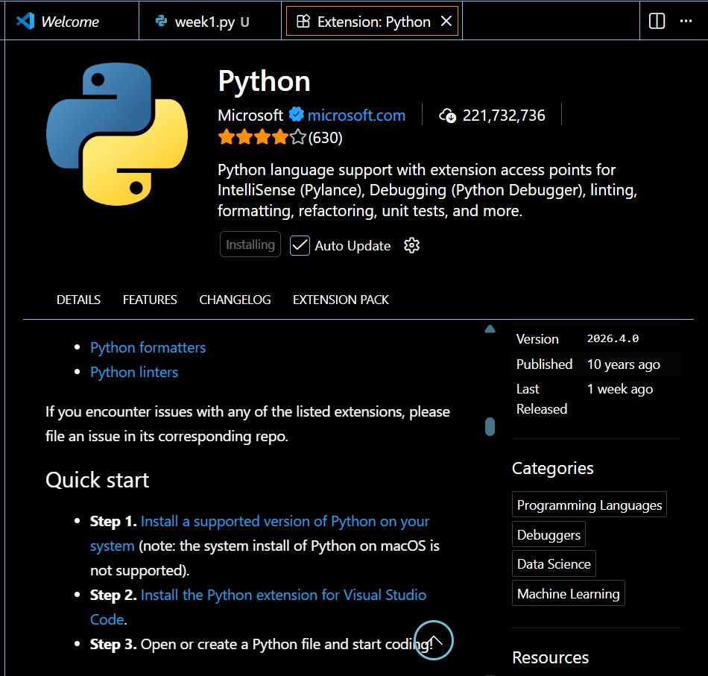
Figure 1: Installation of Python and VS Code
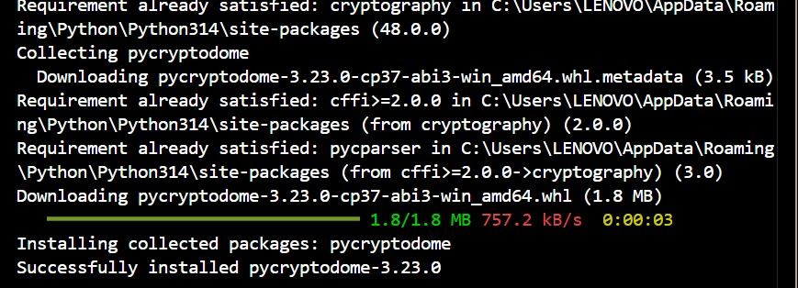
Figure 2: : Installation of Cryptography Libraries
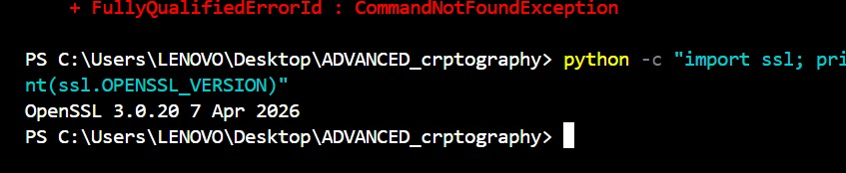
Figure 3: OpenSSL Installation Test
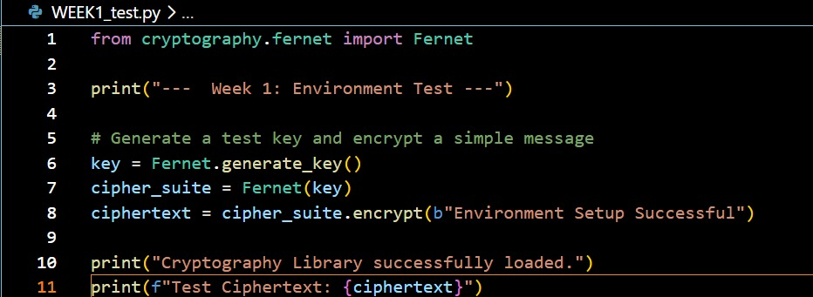
Figure 4: Local Encryption Python Script
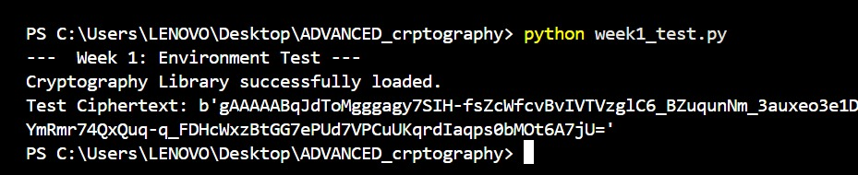
Figure 5: Local Encryption Script Execution
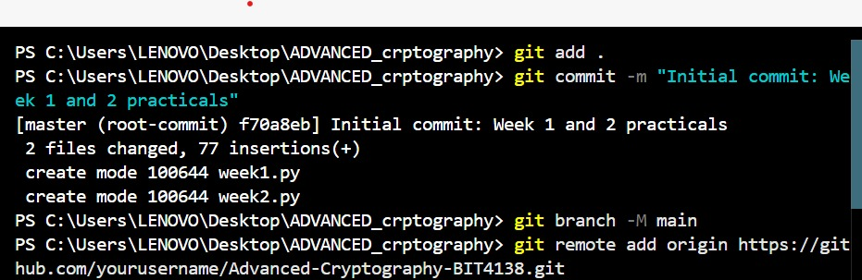
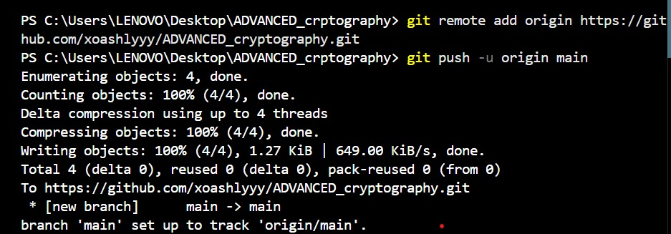
Figure 6: GitHub Repository Initialization

I successfully configured the Python development environment and VS Code for cryptographic operations. OpenSSL was installed for generating secure keys and certificates, and Git was initialized for version control. These tools establish the technical foundation for implementing secure encryption algorithms in subsequent tasks.

Week 2: Classical Cryptography and Cipher Design
Implementation of Classical Encryption Algorithms
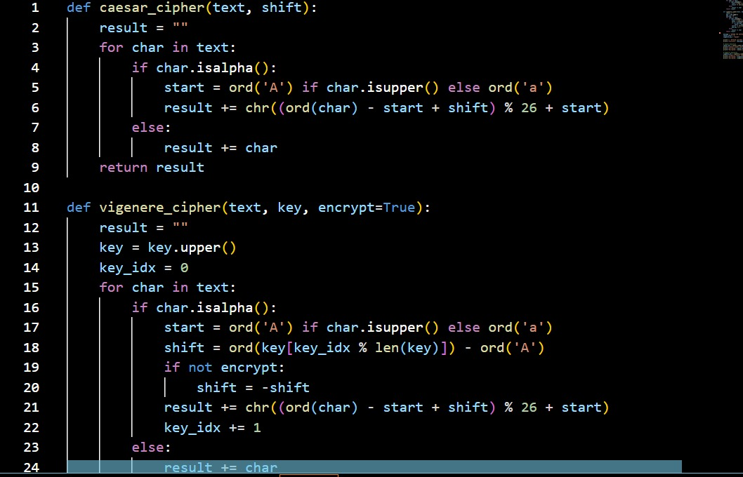
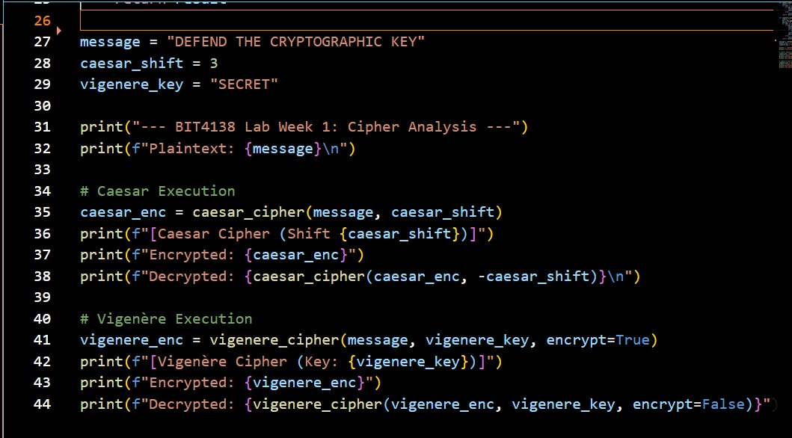
Figure 7: Caesar Cipher & Vigenère Cipher Python Script
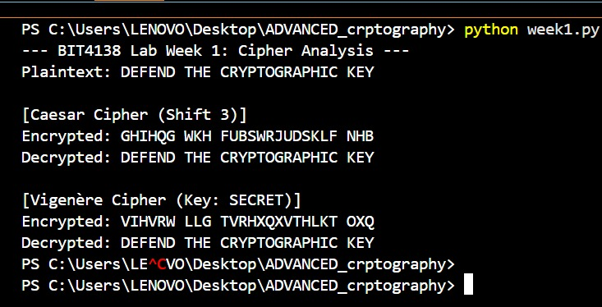
Figure 8: Encryption and Decryption Output

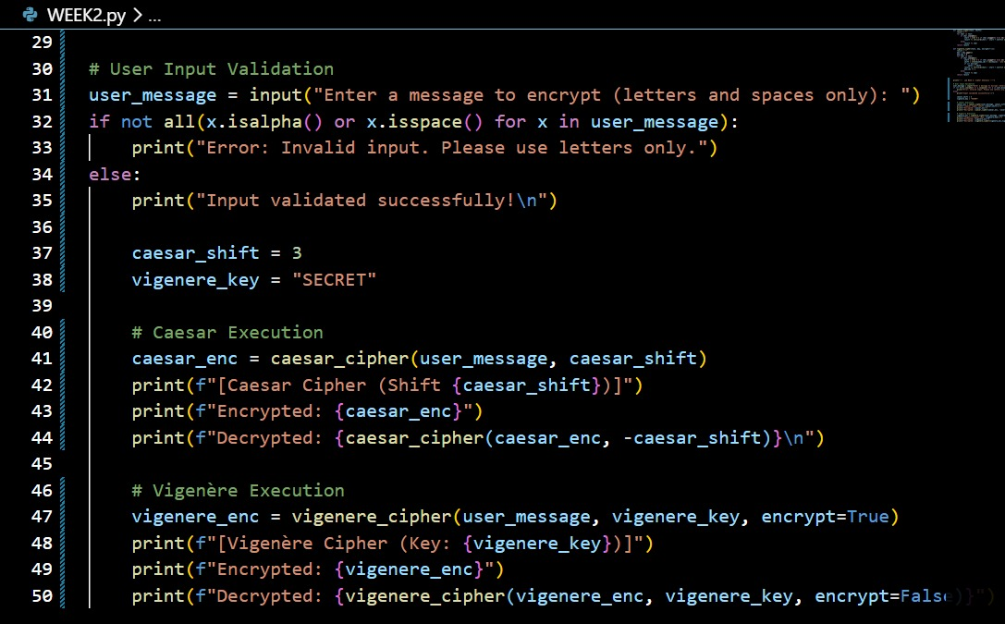
Figure 9: User Input Validation Python Script
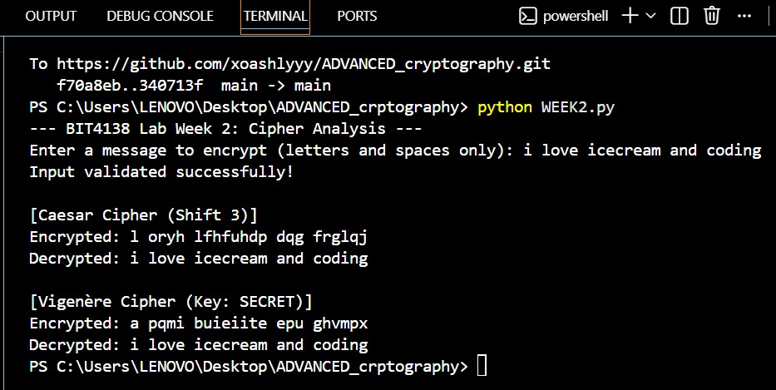
Figure 10: User Input Validation Output
I built interactive Caesar and Vigenere ciphers, testing their encryption workflows. I learned that while Caesar is easily broken due to fixed shifting, Vigenere’s multi-character keys drastically improve security by obscuring character frequencies. The outputs confirm polyalphabetic substitution effectively mitigates the core vulnerabilities of classical monoalphabetic algorithms.

Week 3: Stream Ciphers and Randomness Testing
Implementation of Stream Cipher Systems and Random Sequence Analysis
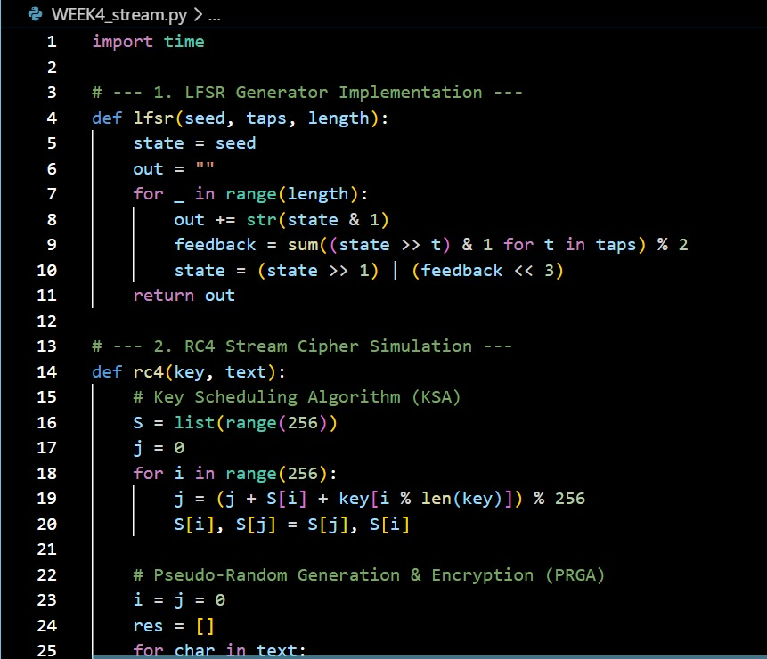
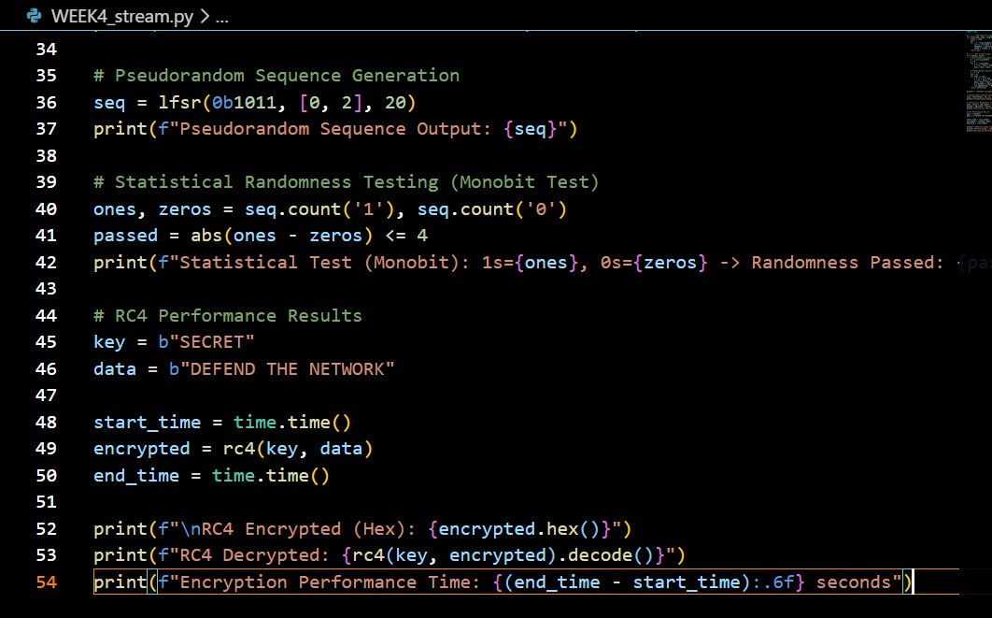
Figure 11: LFSR Generator Implementation Python Code

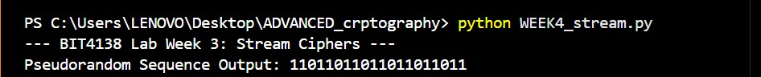
Figure 12: Pseudorandom Sequence Output
Figure 13: Statistical Randomness Testing
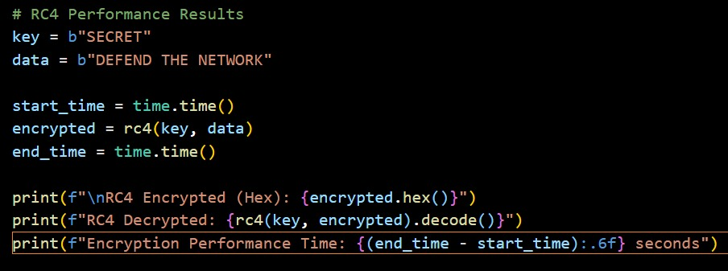
Figure 14: Encryption Performance Python Code
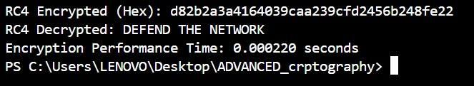
Figure 15: Encryption Performance Results

The RC4 implementation demonstrated real-time stream encryption where data is encrypted bit-by-bit using a keystream. Statistical randomness tests, including frequency analysis, were utilized to evaluate the unpredictability and quality of the generated pseudorandom sequences, ensuring secure cipher operations.

Week 4: Block Cipher Design and AES
Advanced Encryption Standard (AES) and Block Cipher Operations
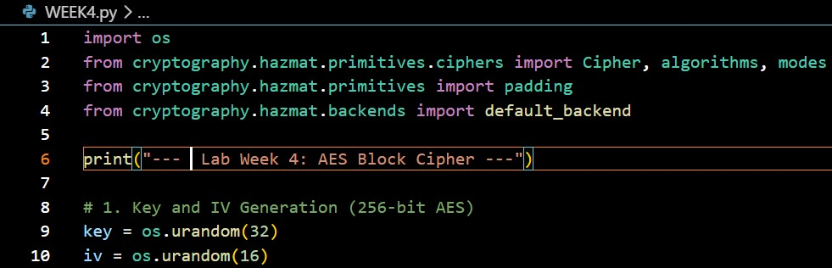
Figure 16: AES Encryption Python Script
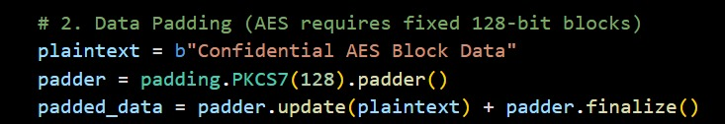
Figure 17: Key Generation Process
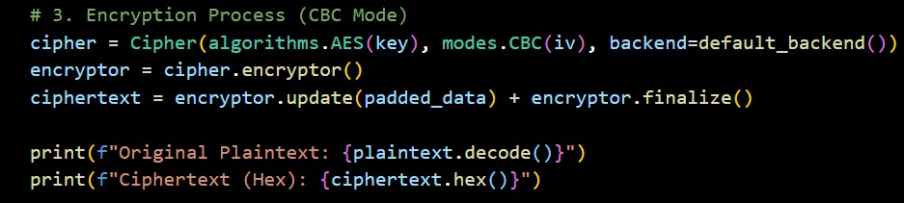
Figure 18: Encryption process
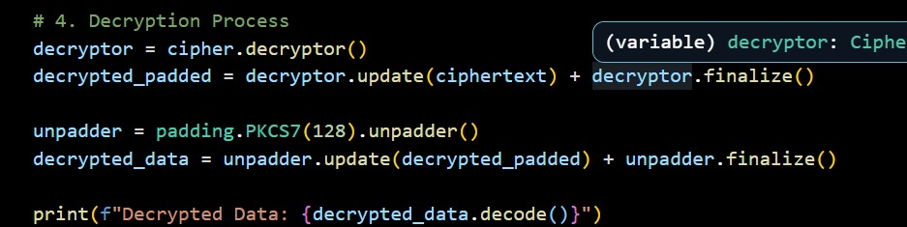
Figure 19: Decryption Process
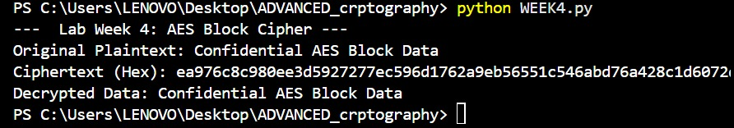
Figure 20: File Encryption & Decryption Results

AES encryption was utilized to securely encrypt text files, emphasizing the importance of symmetric key generation and handling. The implementation highlighted how block ciphers process data in fixed sizes through multiple rounds, successfully demonstrating secure encryption and decryption workflows.

Week 5: Public Key Cryptography (RSA)
Implementation of RSA Encryption and Key Management
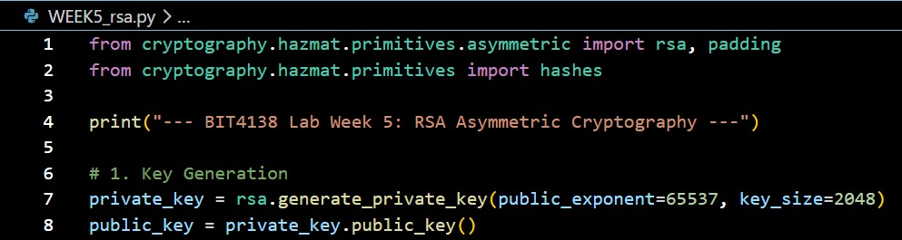
Figure 21: RSA Key Pair Generation
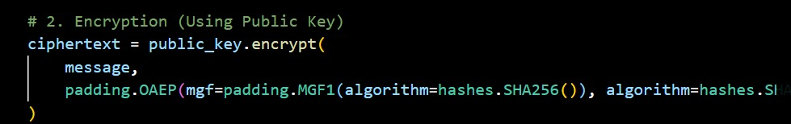
Figure 22: Public Key Encryption Process
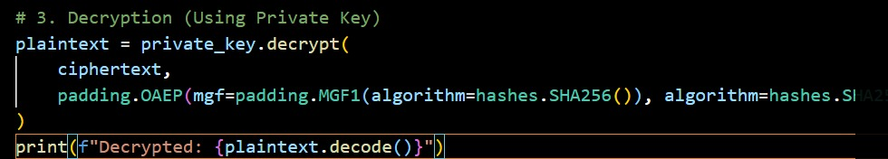
Figure 23: Private Key Decryption Process
Figure 24: Secure Message Transmission
Figure 25: Message Decryption
RSA asymmetric encryption demonstrated secure communication by separating keys into public and private pairs. The implementation highlighted the security advantages of using a public key for message encryption, while successful decryption was restricted strictly to the corresponding private key.

Creative Project: Interactive Crypto Vault Dashboard
1. Environment Setup
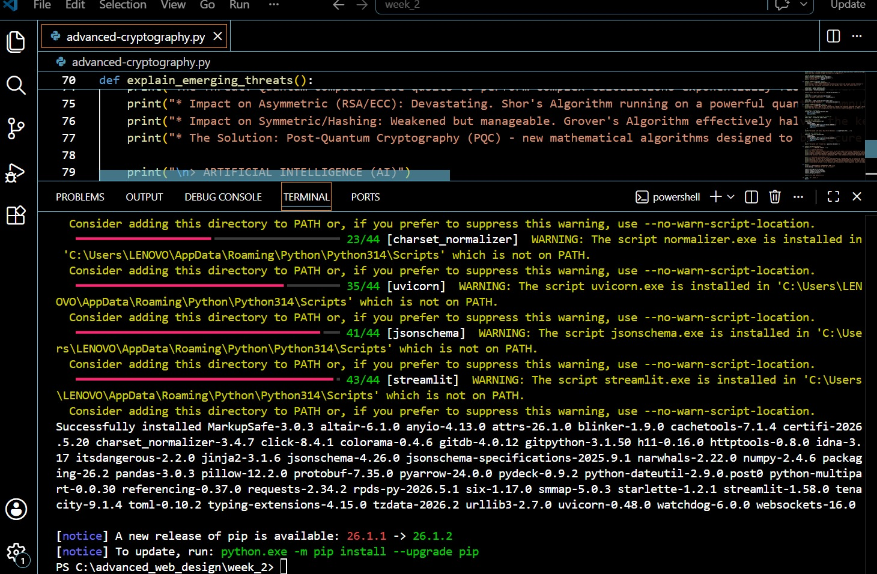
Figure 26: Requirements Installation(CP)

​3. Interface Architecture
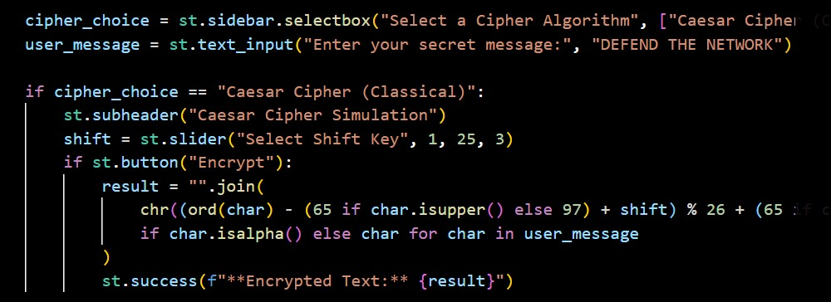
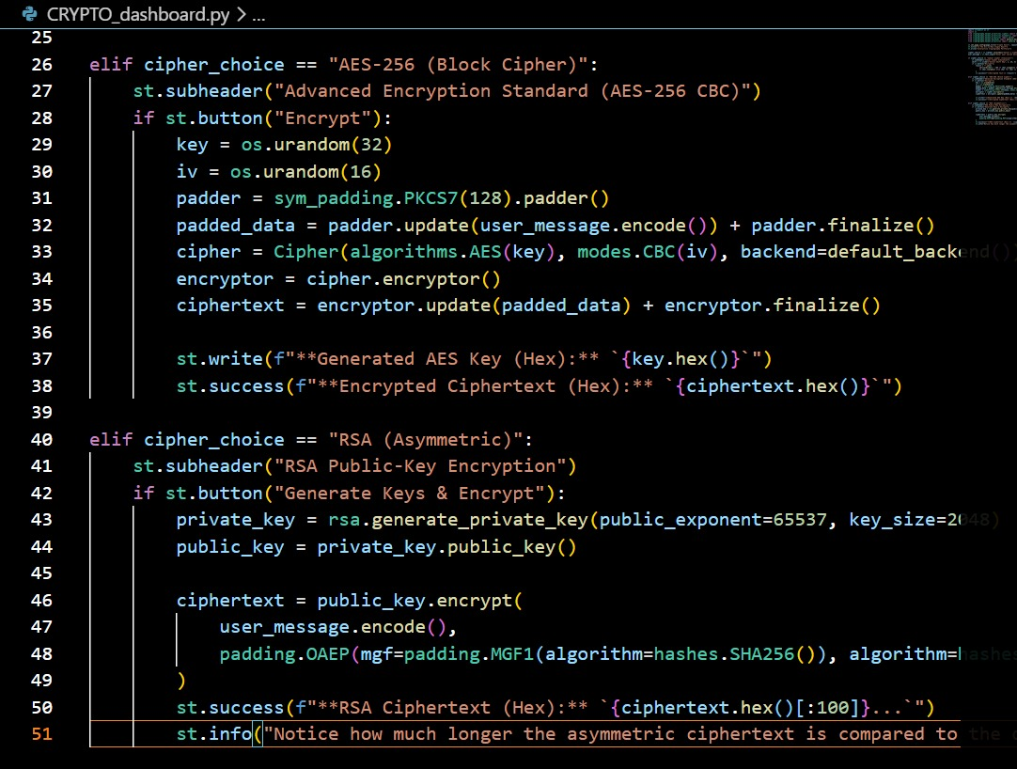
Figure 27: Interface Architecture

​4. Backend Integration
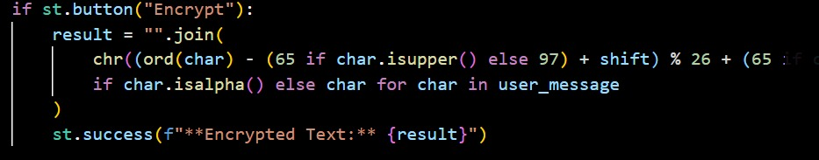
Figure 28: Backend Integration

​5. Input & Event Handling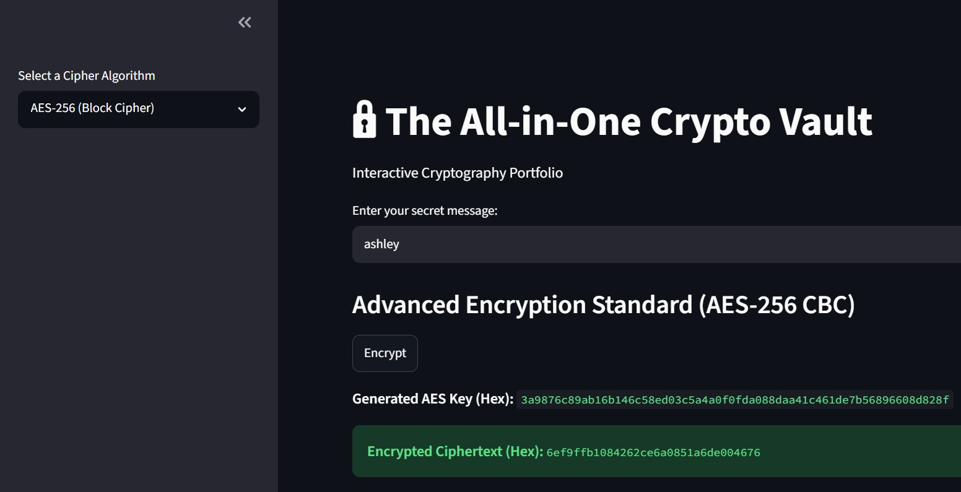
Figure 29: Interactive Encryptor
Building the Interactive Crypto Vault Dashboard using Streamlit successfully bridged complex cryptographic mathematics with an accessible frontend experience. Consolidating standalone cipher scripts into a unified, responsive application allowed for real-time encryption testing. This practical project reinforced how graphical interfaces significantly enhance the usability of advanced security algorithms.
​

Week 6

Task 1: Basic SPN Design & Implementation
​This task involved designing a basic Substitution-Permutation Network (SPN) in Python. The script processes user-entered plaintext through an S-Box mapping layer to achieve confusion, followed by a block-reversal permutation layer to achieve diffusion. The terminal successfully displayed the step-by-step mathematical transformation into secure ciphertext.

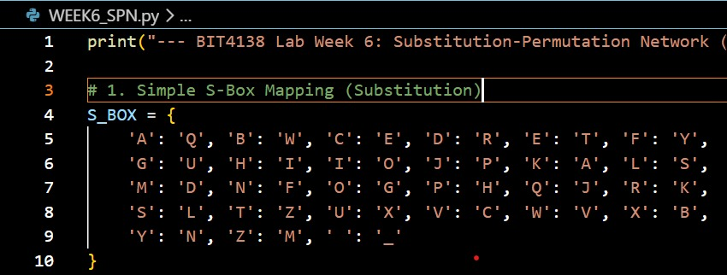
Figure 30: S-Box Dictionary Mapping for the Substitution (Confusion) Layer

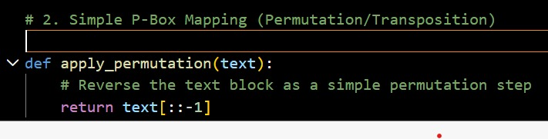
Figure 31: P-Box Logic utilizing Block Reversal for the Permutation (Diffusion) Layer
​

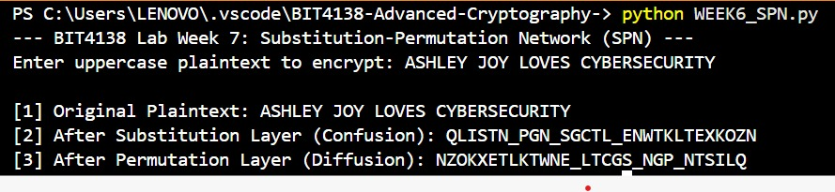
Figure 32: Terminal Output demonstrating the Step-by-Step SPN Encryption Transformation

Practical Task 2: Non-Linearity Investigation

1. What is Non-Linearity in Cryptography?
In symmetric key cryptography, a mathematical function or transformation is defined as linear if it preserves the operation of vector addition and scalar multiplication. In the context of binary fields and bitwise operations, commonly used in block and stream ciphers, a function f is considered linear if it strictly adheres to the principle of superposition:
f(x$⨁$y) = f(x) $⨁$ f(y)
where $⨁$ represents the bitwise Exclusive OR (XOR) operation.

Conversely, a non-linear function is any mathematical transformation that systematically violates this property. For a non-linear function, the relationship between the input bits and the resulting output bits cannot be modeled by a system of linear equations. Mathematically:
f(x$⨁$y) $≠$ f(x) $⨁$ f(y)

In practical block cipher architectures like the Substitution-Permutation Network (SPN), ciphers are divided into layers. The key addition layer and the permutation layer (which shifts or transposes bits) are entirely linear. The non-linear component must be deliberately introduced elsewhere, typically through a localized lookup structure known as a Substitution Box (S-Box).

2. Why is Non-Linearity Critically Important?
Non-linearity forms the core defensive barrier that guarantees the security of a modern cipher. Without a non-linear component, an entire multi-round cryptographic algorithm collapses mathematically into a single, trivial system of linear relationships.

The Vulnerability of Pure Linearity
If a cipher consisted only of linear layers (such as Key Addition and Permutations), an attacker could combine multiple rounds together. Because the composition of any two linear functions is always another linear function, a 10-round or 100-round linear cipher would have the exact same algebraic strength as a 1-round cipher.

Defeating Linear Cryptanalysis
In 1993, researcher Mitsuru Matsui introduced Linear Cryptanalysis, an attack vector that seeks to find high-probability linear approximations of a cipher's internal operations. If an attacker can find a linear path through a cipher, they can record a sufficient number of plaintext-ciphertext pairs and use basic matrix algebra (such as Gaussian elimination) to solve for the secret round keys.
Non-linearity prevents this by breaking the predictable propagation of bit changes, ensuring that any linear approximation holds a probability as close to 0.5 (pure randomness) as possible.

3. How S-Boxes Create Non-Linearity
S-Boxes achieve non-linearity by functioning as localized, highly complex algebraic functions wrapped into fixed lookup tables. Instead of scaling or shifting bits uniformly, modern S-Boxes rely on advanced field mathematics.

Galois Field Inversion (GF($2^{n}$))
In advanced ciphers like the Advanced Encryption Standard (AES), the 8-bit S-Box is designed using the multiplicative inverse over the finite mathematical field GF($2^{8}$), combined with an affine transformation.
Because finding a multiplicative inverse ($x^{-1}$ mod P(x)) is a highly non-linear operation, it yields maximum resistance against both linear and differential cryptanalysis. If an input changes by only a single bit, the non-linear properties of the S-Box cause roughly half of the output bits to flip unpredictably, creating the structural phenomenon known as the Avalanche Effect.

Practical Task 3: SPN vs. Feistel Structure Security Evaluation

1. Architectural Comparison
Modern block ciphers generally utilize one of two primary architectural frameworks to process plaintext into ciphertext: the Substitution-Permutation Network (SPN) or the Feistel Structure.
Substitution-Permutation Network (SPN): This architecture applies mathematical transformations to the entire data block simultaneously during each round. It uses parallel substitution boxes (S-Boxes) to create confusion and permutation boxes (P-Boxes) to create diffusion.
Feistel Structure: This architecture splits the data block into two equal halves (Left and Right). During each encryption round, a non-linear "round function" is applied to the right half using a subkey, and the result is XORed with the left half. The halves are then swapped for the next round. Consequently, only half of the data block is mathematically altered per round.

2. Evaluation Matrix

A. Security
SPN Structure: Highly secure per round. Because the S-Boxes and P-Boxes operate on the entire data block at once, SPN achieves complete diffusion very rapidly (often in just 1 to 2 rounds). However, the security is entirely dependent on the mathematical strength of the S-Boxes; a poorly designed S-Box compromises the entire cipher.

Feistel Structure: Inherently robust design. A unique security advantage of the Feistel network is that the internal round function F does not need to be mathematically invertible (reversible) for the cipher to work. However, because only half the block is encrypted per round, it requires significantly more rounds to achieve the same level of diffusion as an SPN.

B. Performance
SPN Structure: Highly performant, especially in hardware implementations. Because SPN applies its S-Box transformations in parallel across the entire block, it is heavily optimized for modern multi-core processors. It generally requires fewer rounds (e.g., AES uses 10 to 14 rounds) to achieve maximum security, leading to faster encryption and decryption speeds.

Feistel Structure: Slower by comparison. The alternating nature of the left-right block swap limits parallel processing capabilities. Furthermore, to achieve a secure avalanche effect, a Feistel cipher usually requires a higher round count (e.g., DES uses 16 rounds) since only 50% of the bits are manipulated per cycle.

C. Ease of Implementation
SPN Structure: More complex to implement. To decrypt an SPN cipher, the software must contain entirely separate logic blocks. The programmer must design and integrate inverse S-Boxes (reverse lookup tables) and inverse P-Boxes, effectively requiring two distinct algorithms for encryption and decryption.

Feistel Structure: Exceptionally easy to implement. The greatest engineering advantage of a Feistel network is that the encryption and decryption processes use the exact same algorithmic code. To decrypt a message, the system simply runs the ciphertext through the identical encryption function, but feeds the round keys in reverse order.

D. Modern Usage
SPN Structure: This is the dominant architecture in modern cryptography. It is the underlying framework for the Advanced Encryption Standard (AES), which is the current global standard utilized by governments, financial institutions, and secure web protocols (HTTPS/TLS).
Feistel Structure: While historically significant, it is largely considered a legacy architecture. It was the foundation for the Data Encryption Standard (DES), Triple DES (3DES), and Blowfish. While variations of it are still used in some modern ciphers (like Camellia), SPN has largely replaced it for high-performance data protection.

Advanced programming task
​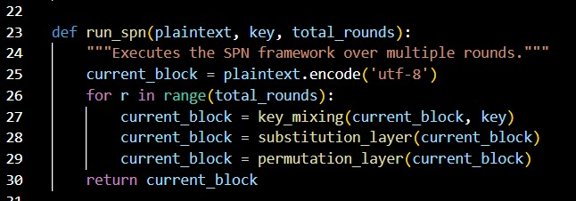
Figure 33: Multi-Round SPN Execution Framework
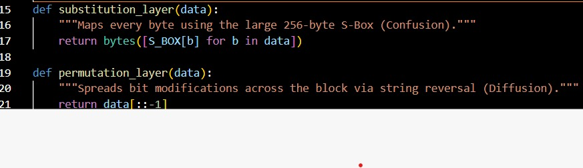
Figure 34: Implementation of Non-Linear Substitution (S-Box) and Linear Permutation Layers
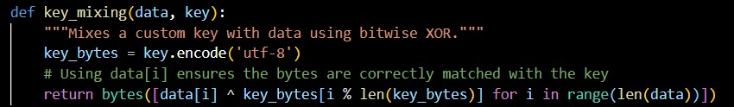
Figure 35: Corrected Key Mixing Logic Utilizing Bitwise XOR

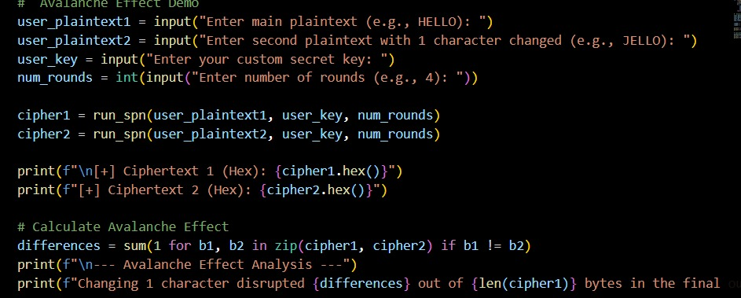
Figure 36: User Execution Logic and Avalanche Effect Mathematical Calculation 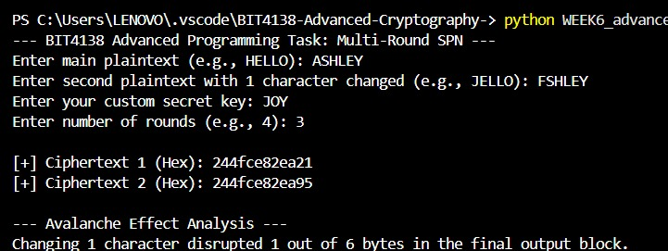
Figure 37: Successful Execution of Multi-Round SPN and Avalanche Effect Demonstration

Challenge task
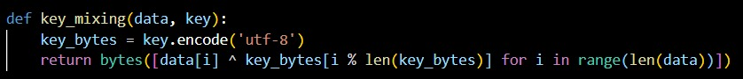
Figure 38: Bitwise XOR Key Mixing Implementation
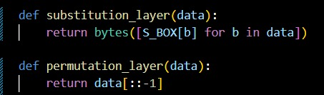
Figure 39: S-Box Substitution and Block Reversal Permutation Functions

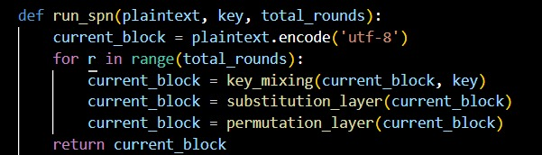
Figure 40: Multi-Round SPN Execution Framework
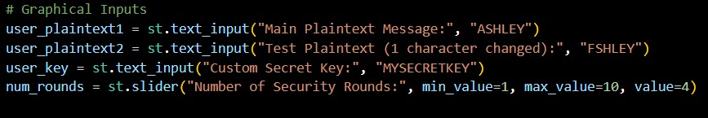
Figure 41: Streamlit Graphical Interface Input Configuration
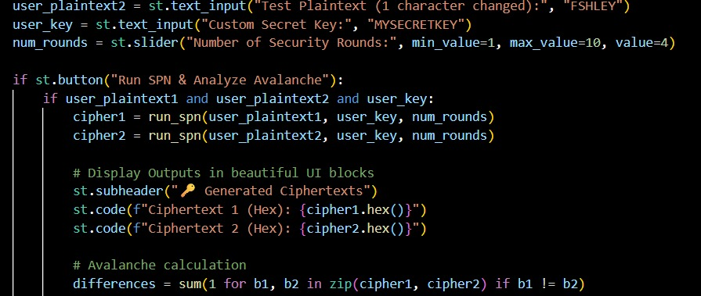
Figure 42: Event Trigger and Avalanche Effect Calculation Logic
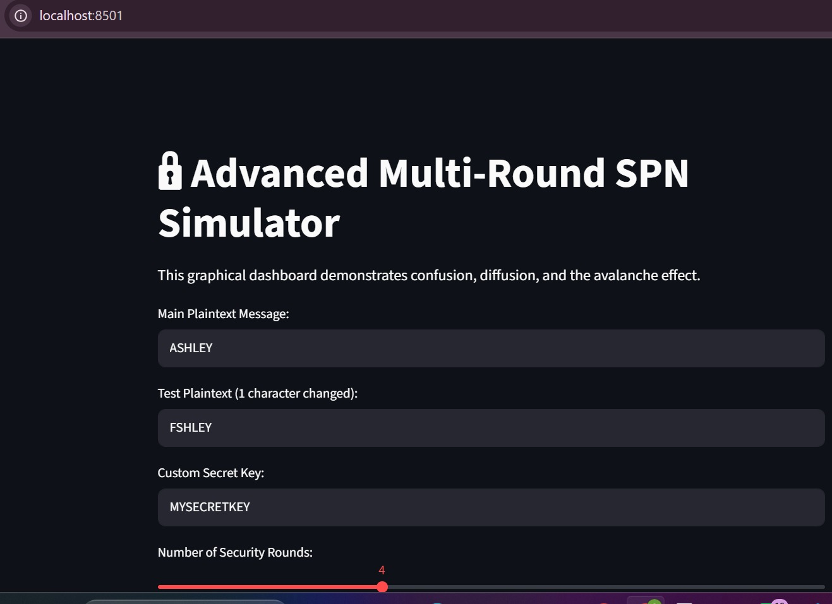
Figure 43: Streamlit Web Dashboard Demonstrating the Advanced Multi-Round SPN Implementation

Security Analysis Report: Advanced Multi-Round SPN

1. Architectural Design Overview
This project upgrades a basic Substitution-Permutation Network (SPN) into a much stronger, multi-round cryptographic simulator. Instead of just processing the data once, the cipher loops the plaintext through multiple encryption cycles (for example, 4 rounds). This repetitive compounding drastically increases the scrambling effect, making the cipher incredibly resistant to statistical cryptanalysis.

2. Component Security Analysis
i) Custom Key Mixing: At the start of the encryption loop, the system mixes in a custom secret key (like MYSECRETKEY) using a bitwise XOR operation. This ensures the final ciphertext is mathematically locked to the user's password. It directly applies Kerckhoffs's Principle, even if an attacker knows exactly how our algorithm works, the data remains totally secure without that exact key.

ii) Enhanced Substitution Layer (Confusion): Upgrading to a massive 256-byte randomized S-Box introduces intense non-linearity. Rather than just shifting letters like a basic classical cipher, this lookup table completely destroys any predictable algebraic relationship between the plaintext and ciphertext. It creates deep "confusion" to neutralize linear cryptanalysis attacks.

iii) Permutation Layer (Diffusion): The block-level permutation mechanism shifts the bytes around to guarantee that localized data changes are spread across the entire block. This satisfies Claude Shannon’s property of "diffusion," ensuring that individual byte patterns disappear entirely into the final output.

3. Avalanche Effect Verification
The most effective way to prove the cipher's structural integrity is by visually simulating the Avalanche Effect. As demonstrated in the dashboard, altering just one single character in the plaintext, such as modifying "ASHLEY" to "FSHLEY", triggers a massive mathematical disruption. Because of the multi-round confusion and diffusion layers compounding on top of each other, that tiny input tweak drastically changes the final hexadecimal output. This divergence confirms that the simulator successfully masks input modifications and can defend against differential cryptanalysis.

Week 7

Task 1: Differential Cryptanalysis Simulation
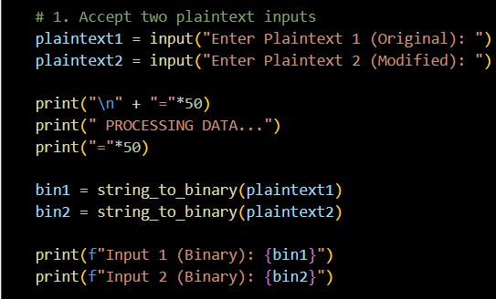
Figure 44: Implementation of Plaintext Input Acceptance and Binary Conversion

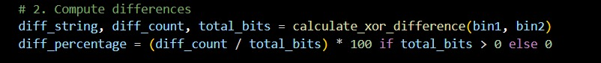
Figure 45: Computation Logic for Bitwise XOR Differences and Percentage Calculation

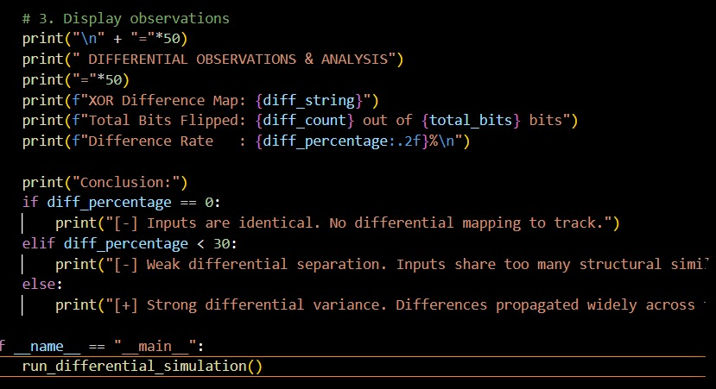
Figure 46: Execution Output for Differential Observations and Final Analytical Conclusion
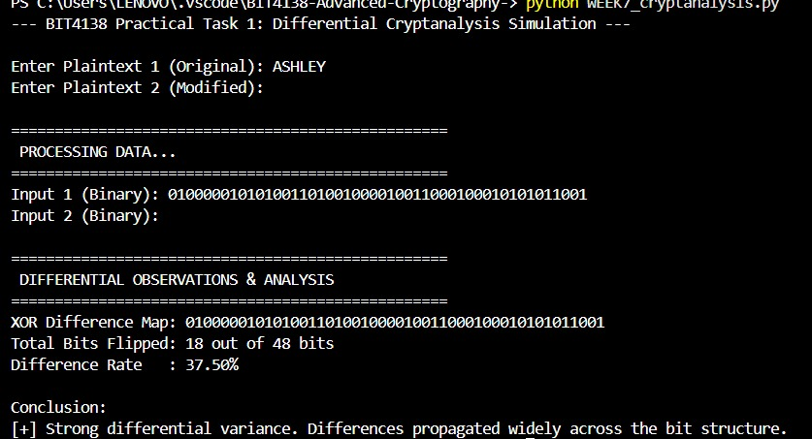
Figure 47: Python script simulation calculating the differential variance and XOR difference map for the plaintext "ASHLEY".
Task 1 Summary

This task involved building a Python-based Differential Cryptanalysis Simulator. It processes two plaintext inputs, converts them to binary, and computes their bitwise XOR difference. The system calculates the percentage of flipped bits to practically demonstrate the avalanche effect and evaluate structural variance between the texts.

Task 2: Block Cipher Security Breach

IN-DEPTH ANALYSIS OF MODERN CRYPTANALYSIS

1. Differential Cryptanalysis
Differential cryptanalysis is a chosen-plaintext attack. Instead of looking at a single encrypted message and trying to work backward, an attacker looks at the *relationship* between two different messages.
Imagine you have a black box, and you want to know what’s inside. If you shine a light into it (a plaintext), the box spits out a reflection (the ciphertext). Differential cryptanalysis is the equivalent of shining two separate lights into the box, changing the angle of the second light by just a tiny fraction, and measuring exactly how the two reflections differ.

Mathematically, the attacker chooses two plaintexts with a specific, known bitwise difference (usually calculated using an Exclusive-OR, or $⨁$ operation). As these two data blocks pass through the multiple rounds of the cipher, the linear layers (like shifts and permutations) behave predictably. The only thing that disrupts the difference is the non-linear Substitution Boxes (S-Boxes). By tracking how specific input differences result in specific output differences, an attacker looks for statistical anomalies. If a certain difference propagates through the S-Boxes with a surprisingly high probability, the attacker can exploit this to deduce the bits of the secret round keys.

Real-World Impact and Example

The story of differential cryptanalysis is one of the most fascinating in computer science. It was introduced to the public in 1990 by researchers Eli Biham and Adi Shamir, who demonstrated that they could use it to theoretically break the Data Encryption Standard (DES) much faster than a brute-force attack (requiring $2^{47}$ chosen plaintexts).

However, the real-world twist was that the creators of DES, IBM and the National Security Agency (NSA), already knew about this attack. They had discovered it secretly back in 1974, which they internally called the "T-attack." Because they knew about it, IBM deliberately designed the DES S-Boxes to be highly resistant to differential patterns. When Biham and Shamir published their paper, they actually proved that if anyone tried to "improve" the DES S-Boxes by randomly changing their values, the cipher became significantly weaker to differential attacks. This proved that DES was structurally optimized against differential tracking decades before the public even knew what it was.

2. Linear Cryptanalysis
While differential cryptanalysis looks at the differences between pairs of data, linear cryptanalysis takes a completely different route. Invented by Mitsuru Matsui in 1993, it is a known-plaintext attack. It is driven by the fact that no mathematical function used in a cipher is perfectly random.The goal of linear cryptanalysis is to find a linear equation that approximates the non-linear behavior of the cipher. An attacker selects specific bits of the plaintext, XORs them with specific bits of the ciphertext, and XORs the result with specific bits of the secret key.

In a perfectly secure, completely random cipher, any linear equation you create should hold true exactly 50% of the time (a probability of 0.5, just like flipping a fair coin). However, because S-Boxes are built using actual math, they are never purely random. If an attacker can find an equation that holds true 50.1% of the time or 49.9% of the time, that tiny deviation (called the bias) is a fatal flaw. By collecting a massive number of known plaintexts and ciphertexts, the attacker can use the law of large numbers to confidently guess the bits of the secret key that make the equation true.

Real-World Impact and Example
Linear cryptanalysis is famous because it moved cipher-breaking from theoretical mathematics into physical reality. In 1994, Matsui didn't just write a paper about breaking DES; he actually did it.

Using $2^{43}$known plaintexts, Matsui deployed a program across 12 HP workstations. The computers ran continuously for 50 days, chewing through the linear equations based on the slight biases in the DES S-Boxes. After 50 days, the computers successfully spit out the correct secret key. This was the very first time an approved, global encryption standard had been practically broken using a structural vulnerability rather than just trying every possible password. This event forced the global community to abandon DES and begin the search for the Advanced Encryption Standard (AES).

3. Algebraic Attacks
Algebraic attacks represent the modern frontier of cryptanalysis. While differential and linear attacks rely on probability and statistics (collecting millions of texts to spot a pattern), algebraic attacks treat the entire cipher as one giant, highly complex mathematical equation.

In this approach, the attacker translates the entire encryption process, the plaintext, the ciphertext, and the internal algorithm steps, into a massive system of multivariable polynomial equations over a finite field (usually GF (2)). In this massive system, the bits of the secret key are treated as the unknown variables ($x_{1}$, $x_{2}$, ...$x_{n}$).

Once the cipher is mapped into algebra, the attacker uses advanced equation-solving algorithms (like Grobner basis algorithms or the XL algorithm) to try and solve for the unknowns. If the math resolves, the key is extracted instantly, without needing millions of data pairs.

Real-World Impact and Example
Algebraic attacks are particularly dangerous to stream ciphers, which often have simpler algebraic structures than block ciphers. However, they caused a massive panic in the block cipher community in 2002. Researchers Nicolas Courtois and Josef Pieprzyk published a paper detailing the "XSL Attack" against AES. Because AES has a very neat, elegant mathematical structure (its S-Box is based on finite field inversion), Courtois and Pieprzyk proved that AES could theoretically be written as a system of 8,000 quadratic equations with 1,600 variables.

At the time, this made headlines, with people fearing AES was broken. Ultimately, the cryptographic community realized that while writing the 8,000 equations was possible, actually solving them required more computing power than exists in the universe. The XSL attack is currently considered impractical, but it serves as a stark real-world reminder: if a cipher's math is too elegant and rigid, it becomes vulnerable to being solved just like a high school algebra problem.

Conclusion
The evolution of block ciphers is a direct reaction to these three analytical techniques. Modern algorithms like AES survive today specifically because their designers studied these attacks. AES uses highly complex finite field mathematics to ensure there are no differential patterns to track (stopping Biham and Shamir) and utilizes the "Wide Trail Strategy" to ensure no linear bias survives past two rounds (stopping Matsui). As computing power grows and algebraic solvers become more efficient, the arms race between cryptographers and cryptanalysts will undoubtedly continue into the quantum era.

Task 3: Security Evaluation of AES

1. Why AES is Resistant to Differential Cryptanalysis
Differential cryptanalysis relies on tracking how a specific mathematical difference between two plaintexts propagates through a cipher's non-linear layers (S-boxes) to find a predictable pattern.
AES is effectively immune to this because of how its Substitution Box (S-Box) is built. Instead of using random lookup tables, the AES S-box is algebraically constructed using the multiplicative inverse over the Galois Field GF ($2^{8}$). followed by an affine transformation.

The Result: This specific mathematical structure guarantees the lowest possible "differential uniformity." The maximum probability of any differential path occurring through a single AES S-Box is incredibly low $2^{-6}$). Across just 4 rounds of encryption, the probability of tracking a difference drops well below $2^{-128},$meaning an attacker would need more plaintexts than physically exist to track a differential pattern.

2. Why AES is Resistant to Linear Cryptanalysis
Linear cryptanalysis attempts to find a linear equation that can approximate the non-linear behavior of the cipher over multiple rounds. AES defeats this using the Wide Trail Strategy, a core design principle implemented by Daemen and Rijmen. This strategy focuses on maximizing diffusion through the ShiftRows and MixColumns operations.
The Result: The Wide Trail Strategy mathematically guarantees that any linear path chosen by an attacker must pass through at least 25 active S-boxes over the course of just 4 rounds. Because each S-box introduces non-linear randomness, forcing an equation through 25 of them drives the linear correlation bias practically to zero. The attacker simply cannot gather enough data to solve the linear equations.

3. Modern Research Findings on AES Security
Decades of intense academic scrutiny have confirmed that AES remains highly secure, though cryptographers have discovered some fascinating theoretical boundaries:
- Biclique Cryptanalysis (2011): Researchers Bogdanov, Khovratovich, and Rechberger published the first successful attack on the full AES-128 algorithm. Using a technique called the "biclique attack," they recovered the key in $2^{126.1}$ operations (slightly faster than a $2^{128}$ brute force attack). While a massive theoretical breakthrough, it is completely impractical for real-world hacking.
- Related-Key Attacks (2009): Research by Alex Biryukov and others demonstrated that AES-192 and AES-256 are vulnerable if an attacker can observe the cipher operating under two different, but mathematically related, keys. This highlights a slight weakness in the AES key schedule, though it rarely applies to proper real-world implementations.
- The Quantum Threat (Grover's Algorithm): Modern research into quantum computing shows that Grover's algorithm will effectively halve the key size of symmetric ciphers. This means AES-128 will eventually drop to 64-bit security (which is breakable). Consequently, modern security agencies now recommend transitioning to AES-256, which will drop to 128-bit security—keeping it completely safe even in the post-quantum era.

Conclusion
AES remains the global gold standard for symmetric encryption. It is structurally immune to classical statistical attacks (Linear and Differential) due to its Galois Field S-box and Wide Trail Strategy. To date, the only practical way to bypass AES is not by attacking the math, but by stealing the keys through poor implementation (Side-Channel Attacks) or human error.

Advanced Programming Task

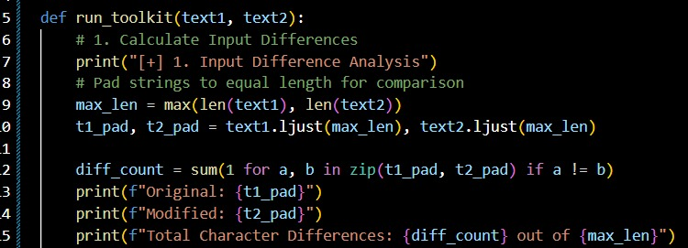
Figure 48: Input Difference Analysis and String Padding Logic

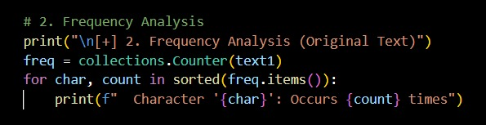
Figure 49: Frequency Analysis Implementation using collections.Counter
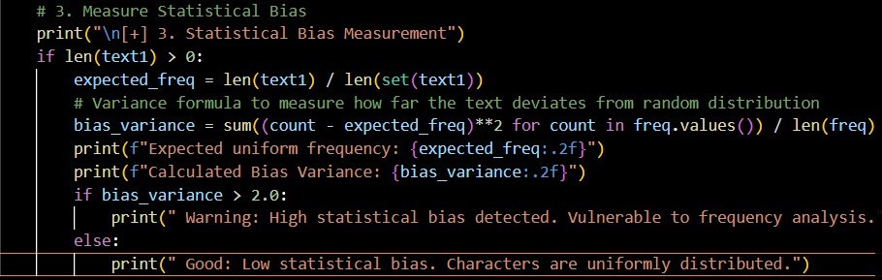
Figure 50: Statistical Bias Variance Calculation Algorithm
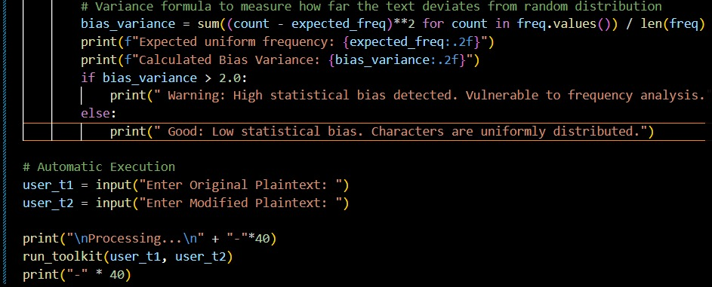
Figure 51: User Input Acceptance and Automatic Toolkit Execution Logic

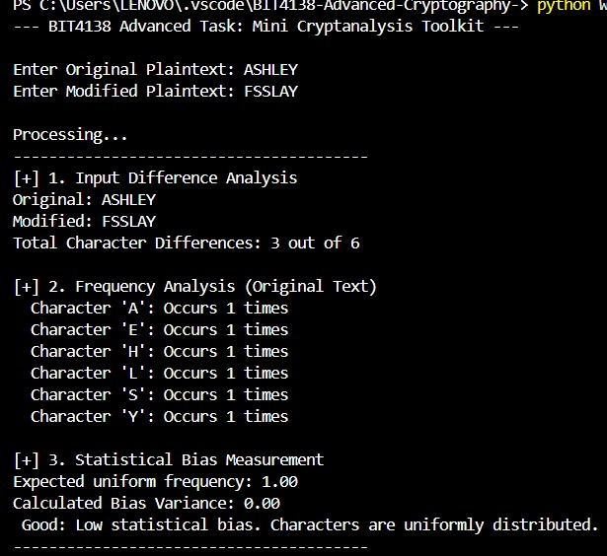
Figure 52: Complete Terminal Output of the Mini Cryptanalysis Toolkit Demonstrating Difference, Frequency, and Statistical Bias Analysis

This task involved developing a terminal-based Mini Cryptanalysis Toolkit in Python. The script automates input difference testing via character padding, performs frequency analysis using the counter module, and quantifies statistical bias through variance calculations. It successfully identifies structural patterns and vulnerabilities to frequency analysis without requiring a graphical interface.

Challenge task
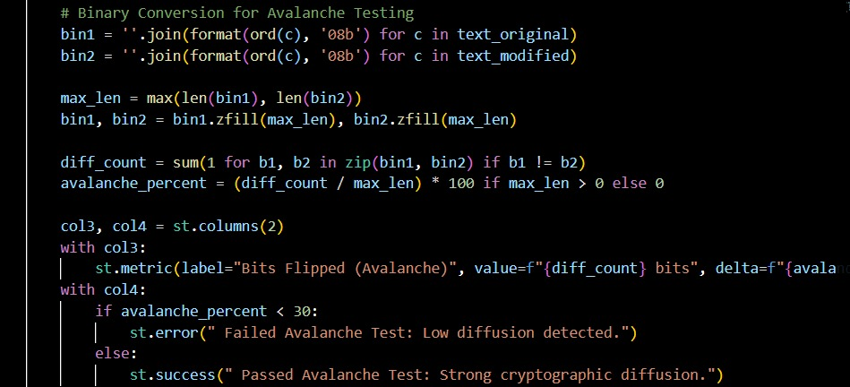
Figure 53: Core Difference Calculation and Avalanche Percentage Logic
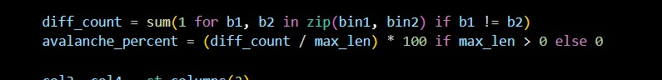
Figure 54: Binary Conversion and Avalanche Metric UI Implementation
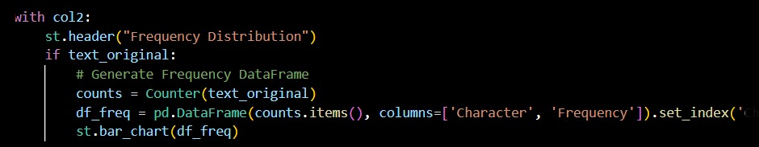
Figure 55: Character Frequency DataFrame and Bar Chart Generation
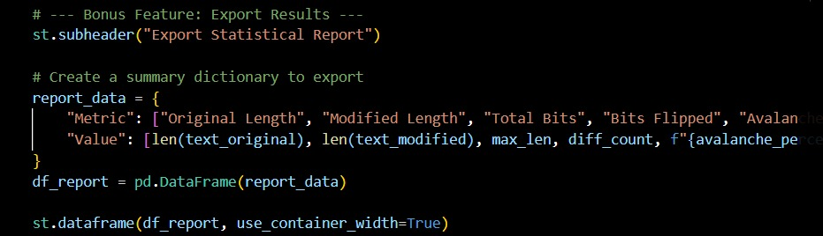
Figure 56: Statistical Data Dictionary and UI Table Rendering
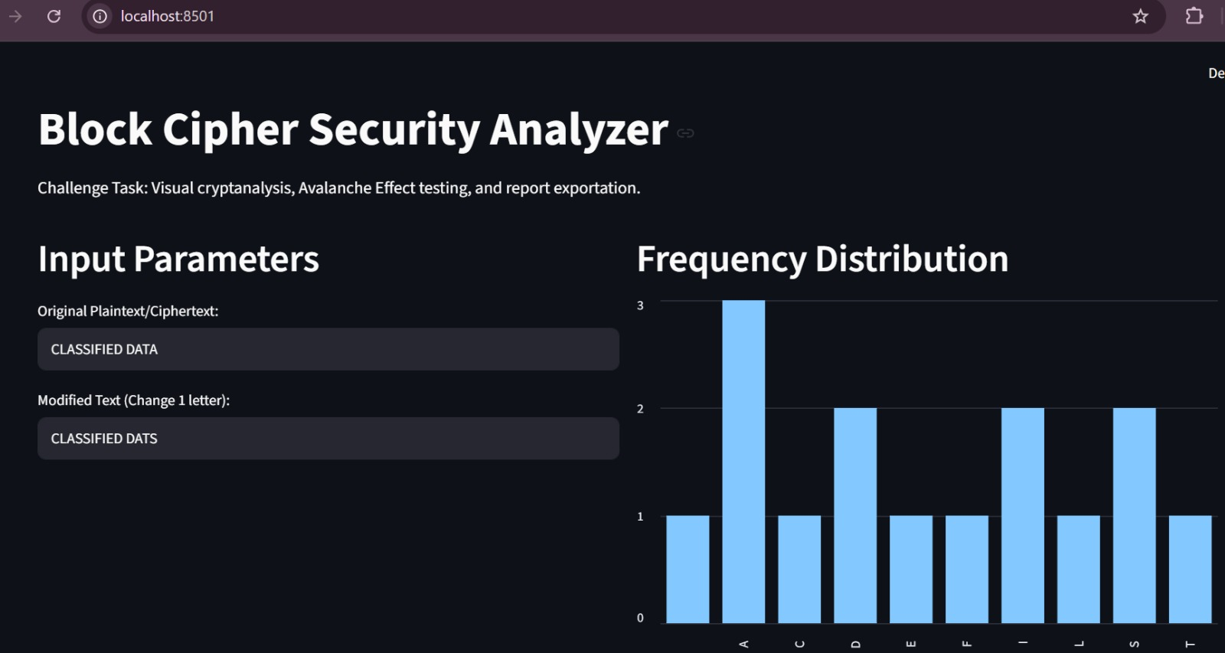
Figure 57: Security Analyzer Dashboard Displaying Input Parameters and Frequency Visualization
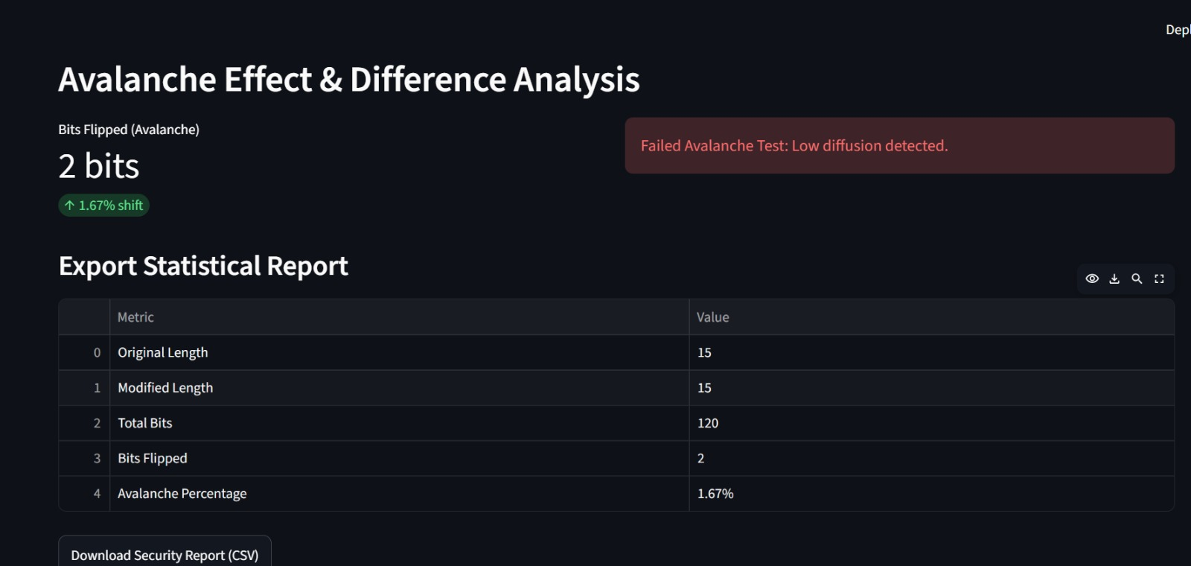
Figure 58: Security Analyzer Dashboard Displaying Avalanche Metrics and CSV Export Interface

This task implements an interactive Block Cipher Security Analyzer using Streamlit. The graphical dashboard performs visual cryptanalysis, evaluates the Avalanche Effect through bitwise comparisons, and visualizes character frequencies using dynamic bar charts. It successfully integrates bonus features, allowing users to instantly export their statistical analysis results to CSV.

WEEK 8

Practical Task: OpenSSL Certificate Inspection
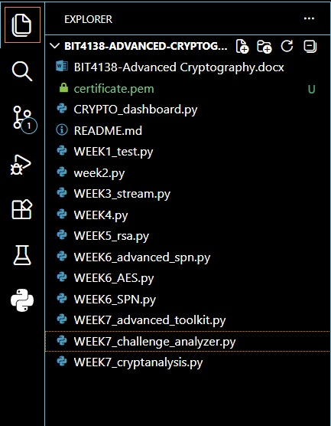
Figure 59: Successful Download of the PEM Certificate into the Project Directory
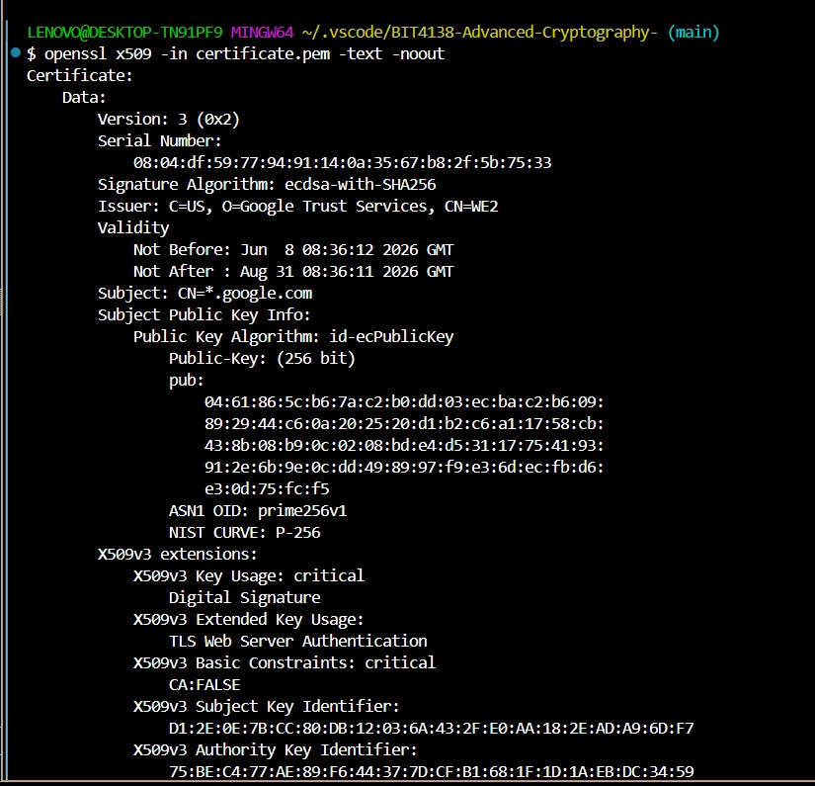
Figure 60: OpenSSL Inspection Displaying Certificate Issuer, Subject, and Expiry Date

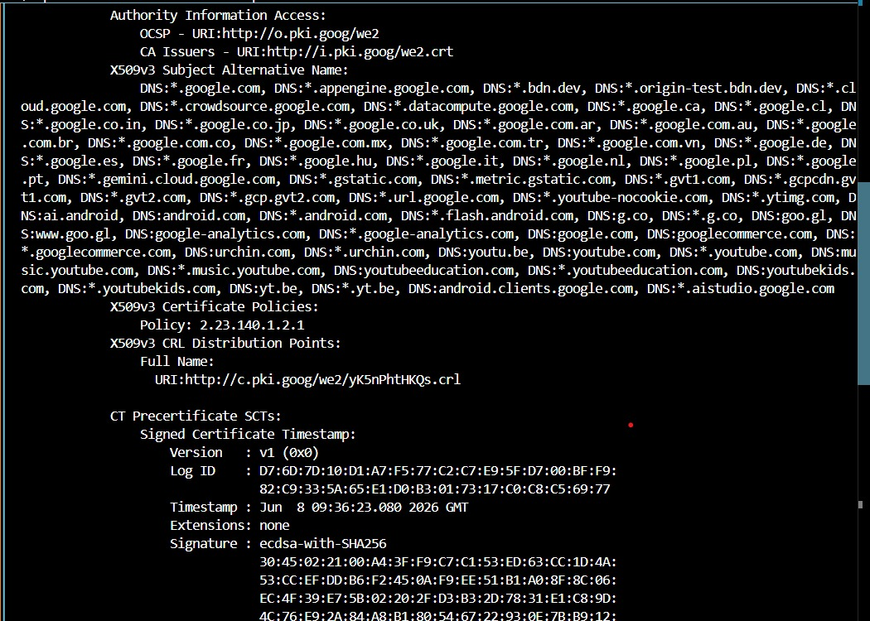
Figure 61: OpenSSL Output Detailing Subject Alternative Names (SAN) and Extensions
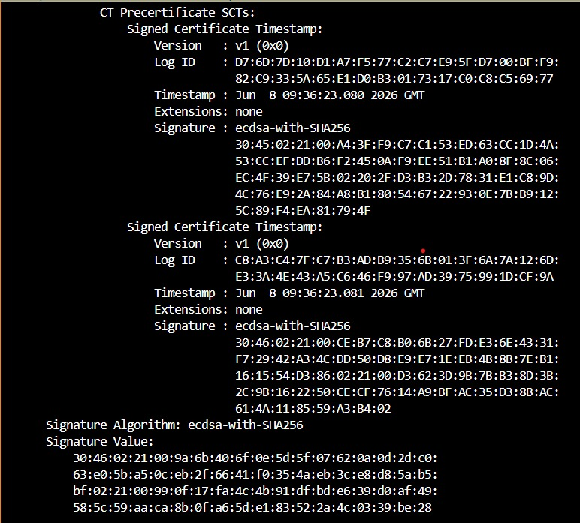
Figure 62: OpenSSL Output Verifying the ECDSA Signature Algorithm and Hexadecimal Value
In Week 8, I explored advanced cryptanalysis and PKI security by developing Python tools to measure statistical bias and the avalanche effect. Additionally, I utilized OpenSSL to inspect a live digital certificate, successfully identifying the following key cryptographic parameters:
- Subject: CN=*.google.com
- Issuer: C=US, O=Google Trust Services, CN=WE2
- Signature Algorithm: ecdsa-with-SHA256
- Expiry Date: Aug 31 08:36:11 2026 GM

DIGITAL CERTIFICATE SECURITY INCIDENT REPORT
Case Study: The 2024 DigiCert Domain Control Validation (DCV) Flaw
1. Organization Involved
DigiCert, Inc. is one of the world’s largest commercial Certificate Authorities (CAs), providing Public Key Infrastructure (PKI) and SSL/TLS certificates to millions of websites, including major financial and government institutions.

2. Cause of the Incident
In July 2024, DigiCert disclosed a critical flaw in its Domain Control Validation (DCV) process. To prove domain ownership, applicants place a random string in their DNS CNAME records. A bug in DigiCert's legacy system failed to check for a mandatory underscore (_) prefix in these strings. This loose validation meant attackers could theoretically bypass ownership checks and fraudulently obtain certificates for domains they didn't fully control.

3. Impact on Users
To comply with strict CA/Browser (CA/B) Forum rules, DigiCert had to abruptly revoke approximately 83,000 active SSL/TLS certificates within exactly 24 hours.
Outages: Many companies missed the tight deadline, causing their websites to go offline with "Not Secure" browser warnings.
Operational Strain: IT teams were forced into emergency weekend shifts to manually replace certificates across their infrastructure.

4. Corrective Actions Taken
- Immediate Patching: DigiCert updated the CNAME validation logic to strictly enforce exact string matching.
- Mandatory Revocation: They strictly enforced the 24-hour revocation deadline for all 83,000 certificates, despite massive pushback from enterprise clients.
- Customer Triage: Emergency dashboards were created in their portal to help administrators quickly identify and reissue flagged certificates.
- Public Disclosure: A detailed public incident report was filed to the Mozilla security mailing list.

5. Lessons Learned for PKI Security
- Automated Management is Mandatory: Organizations relying on manual certificate deployment suffered the most outages. Automated protocols like ACME are essential for surviving sudden 24-hour revocation windows.
- Audit Legacy Code: CAs must continuously audit older validation engines against updated industry baseline requirements.
- Compliance Over Convenience: DigiCert's choice to crash client websites rather than miss the deadline proves that in PKI, strict cryptographic trust and compliance will always supersede business convenience.

WEEK 9

Individual assignment
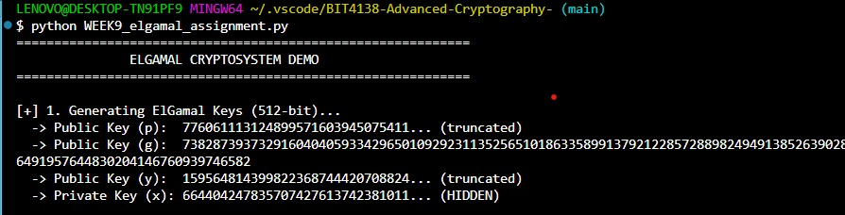
Figure 63 (Key Generation output): Execution of ElGamal Cryptosystem and 512-bit Key Generation
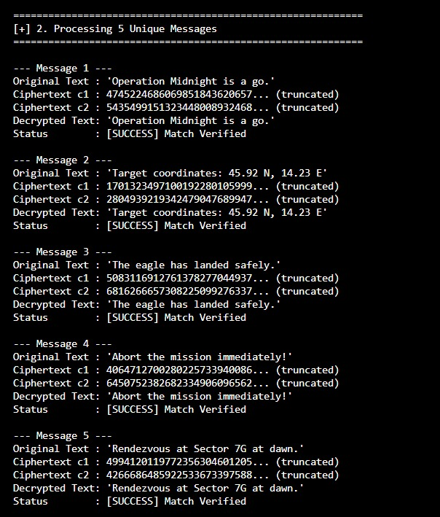
Figure 64(Processing 5 messages): Successful Encryption, Decryption, and Verification of Five Unique Messages
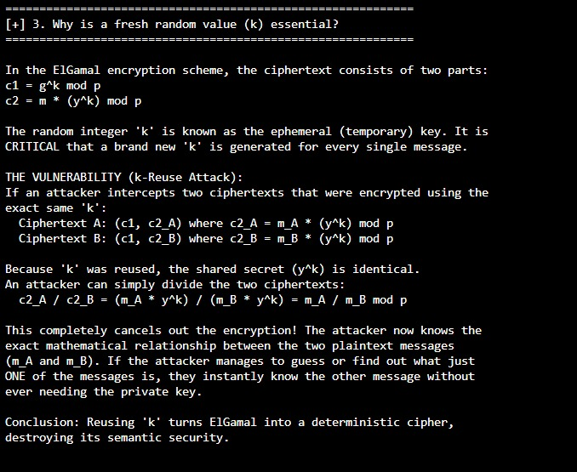
Figure 65(k-Reuse explanation): Terminal Output Explaining the Security Necessity of the Ephemeral Key (k) in ElGamal

Real-World Uses of the RSA Cryptosystem: Securing the Web with SSL/TLS (HTTPS)

Introduction
The Rivest-Shamir-Adleman (RSA) algorithm, developed in 1977, is one of the most pivotal cryptographic systems in computing history. While modern cryptography has introduced newer algorithms like Elliptic Curve Cryptography (ECC), RSA remains universally implemented as the foundational backbone for securing internet communications. The most ubiquitous, everyday application of RSA is its role in the SSL/TLS protocols that power HTTPS (Hypertext Transfer Protocol Secure).

Every time a user visits a website showing a padlock icon in the browser address bar, RSA is likely operating beneath the surface to authenticate the server and securely initiate the encrypted session.

How RSA Powers the SSL/TLS Handshake
When a user attempts to connect to a secure website (e.g., their mobile banking portal), an intricate cryptographic dance called the "TLS Handshake" takes place in milliseconds. RSA plays two distinct and critical roles in this process:

1. Digital Signatures and Authentication (The Certificate)
Before a browser trusts a website, it must verify the website's identity. The website's server sends the browser a Digital Certificate (often issued by a Certificate Authority). This certificate contains the server's public RSA key.

To prove it genuinely owns this public key, the server uses its hidden Private RSA Key to digitally sign a piece of data during the handshake. The browser uses the public key from the certificate to verify this signature. If the RSA math aligns—specifically, if signature^e mod n == hash—the browser is cryptographically guaranteed that it is communicating with the legitimate server, completely neutralizing "Man-in-the-Middle" (MitM) attacks.

2. Secure Key Exchange
Symmetric encryption (like AES) is incredibly fast and ideal for encrypting heavy web traffic (like streaming video or downloading files). However, symmetric encryption requires both the user and the server to share a secret session key. Passing this secret key over the open internet is dangerous.

Historically, RSA solved this exact problem. The browser generates a random "pre-master secret" (the symmetric key) and uses the server's Public RSA Key to encrypt it. Because of the mathematical asymmetry of RSA, only the server holding the Private RSA Key can decrypt it. Once the server decrypts the pre-master secret, both parties successfully hold the symmetric key without ever transmitting it in plain text.

(Note: While modern TLS 1.3 heavily favors Diffie-Hellman for key exchange to provide Perfect Forward Secrecy, RSA is still heavily utilized for the authentication portion of the handshake).

The Security Paradigm and Challenges
The security of HTTPS via RSA relies entirely on the mathematical difficulty of prime factorization. Real-world SSL/TLS configurations currently enforce a minimum RSA key size of 2048 bits. A modulus (n) of this size is a number approximately 617 decimal digits long.

As demonstrated by algorithms like Pollard’s Rho and the General Number Field Sieve, if a modulus is too small, supercomputers can factor $n$ back into its primes ($p$ and $q$), allowing attackers to recreate the private key and strip away all encryption. Consequently, the industry is already preparing for larger keys and eventual post-quantum cryptography to replace RSA as quantum computing capabilities advance.

Conclusion
Without the RSA algorithm, e-commerce, digital banking, and private communications over the internet would be functionally impossible. By leveraging the mathematical properties of large primes, RSA ensures that a user can securely negotiate a session key and verify the exact identity of an HTTPS website across an insecure, untrusted network.

I developed a comprehensive Python-based RSA cryptosystem. The program successfully generates 512-bit keys, encrypts and decrypts text, and performs digital signature verification. It also implements the Miller-Rabin primality test and demonstrates the critical vulnerability of small prime moduli using Pollard’s Rho factorization.

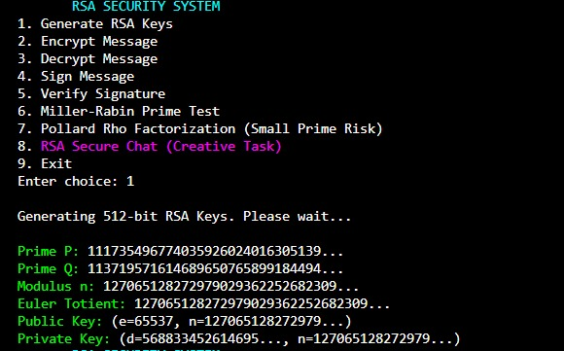
Figure 66 (Option 1 - Key Generation): Generation of 512-bit RSA Public and Private Keys
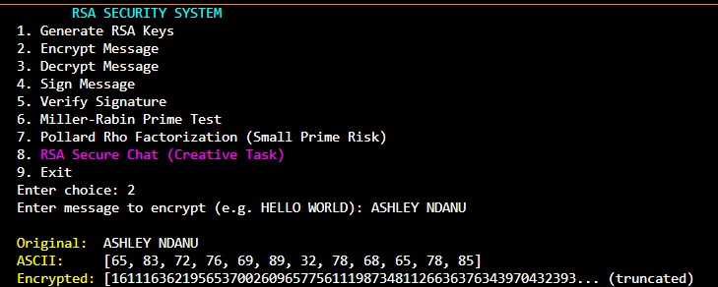
Figure 67(Option 2 - Encryption): RSA Encryption of Plaintext into ASCII and Ciphertext Arrays
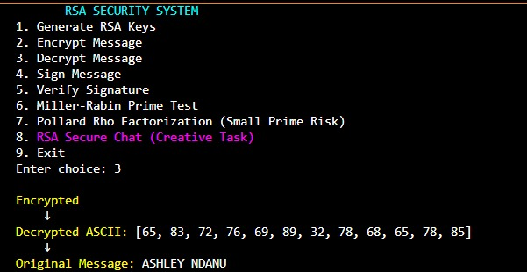
Figure 68(Option 3 - Decryption): RSA Decryption Process Reverting Ciphertext to Original Plaintext
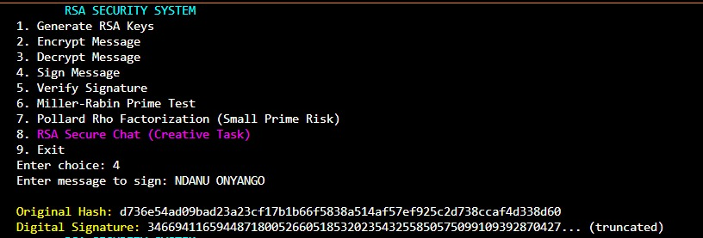
Figure 69 (Option 4 - Sign Message): Generating an RSA Digital Signature via SHA-256 Hashing
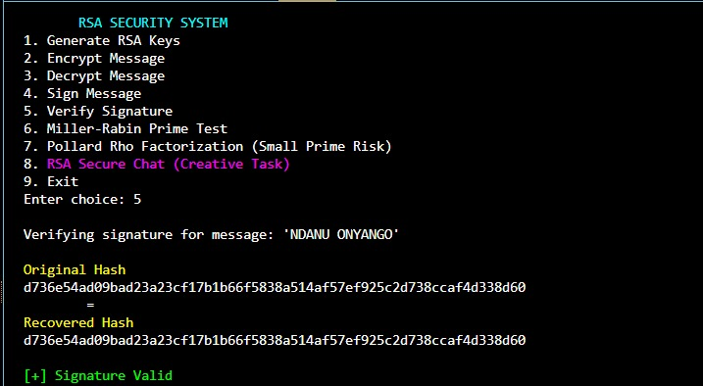
Figure 70 (Option 5 - Verify Signature): Successful Cryptographic Verification of the RSA Digital Signature
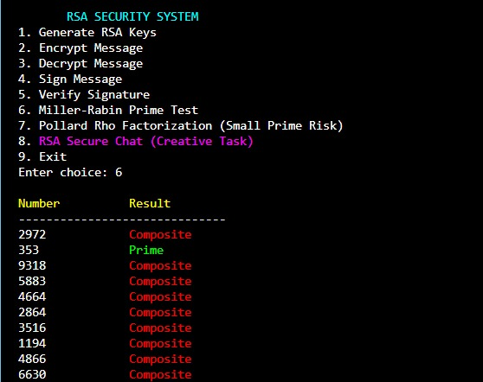
Figure 71 (Option 6 - Miller-Rabin): Execution of the Miller-Rabin Primality Test on Random Integers
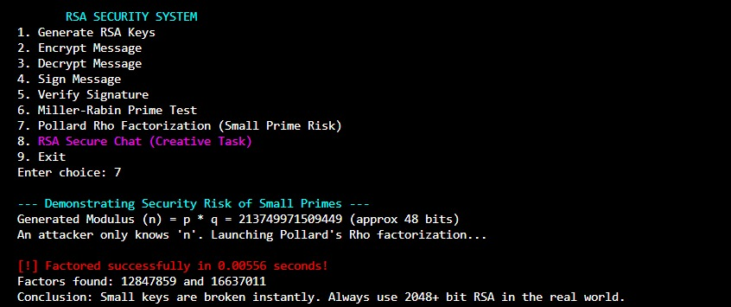
Figure 72 (Option 7 - Pollard Rho): Pollard's Rho Factorization Demonstrating the Vulnerability of Small Moduli
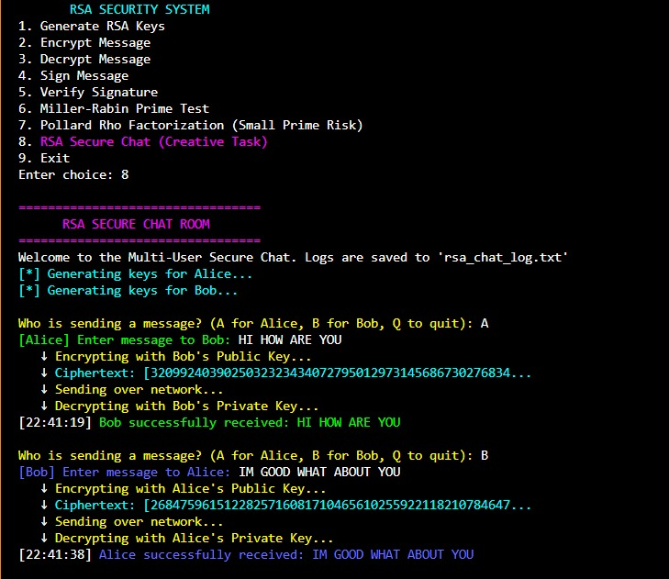
Figure 73 (Option 8 - Secure Chat): RSA Secure Chat Simulation Demonstrating End-to-End Encrypted Message Exchange

WEEK 10: ElGamal Cryptosystem and Elliptic Curve Cryptography
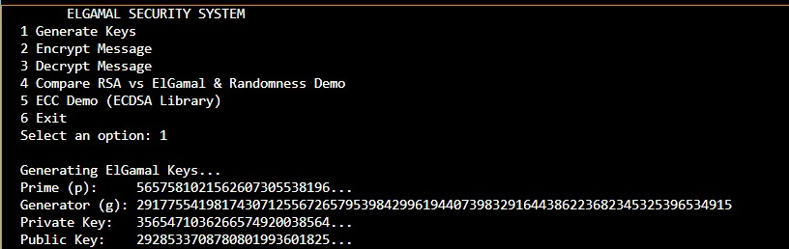
Figure 74(Key Generation): ElGamal Key Generation Displaying Prime, Generator, and Key Pairs
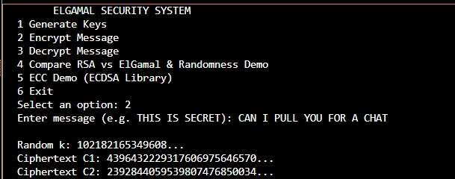
Figure 75 (Encryption): ElGamal Message Encryption Showing the Ephemeral Key and Ciphertext Pair

Figure 76 (Decryption): Successful Decryption of the ElGamal Ciphertext to the Original Plaintext

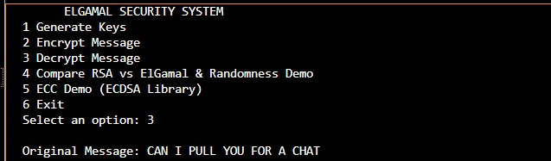
Figure 77 (Randomness & Benchmark): Randomness Demonstration and Execution Time Benchmarking for RSA vs. ElGamal
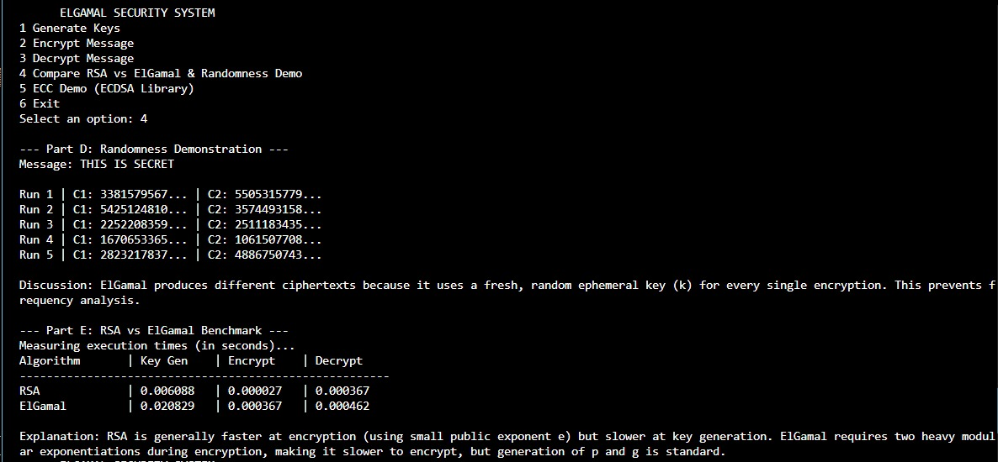
Figure 78 (ECC Demo): Elliptic Curve Cryptography (ECC) Demonstration Showcasing Key Generation and Signature Verification
Week 10 Activity Summary
This activity demonstrates a custom Python application implementing the ElGamal cryptosystem and Elliptic Curve Cryptography (ECC). The screenshots showcase successful key generation, encryption, and decryption. Furthermore, it highlights ElGamal's semantic security through randomized ciphertexts, benchmarks its performance against RSA, and successfully executes an ECC digital signature verifiation.

Creative Challenge
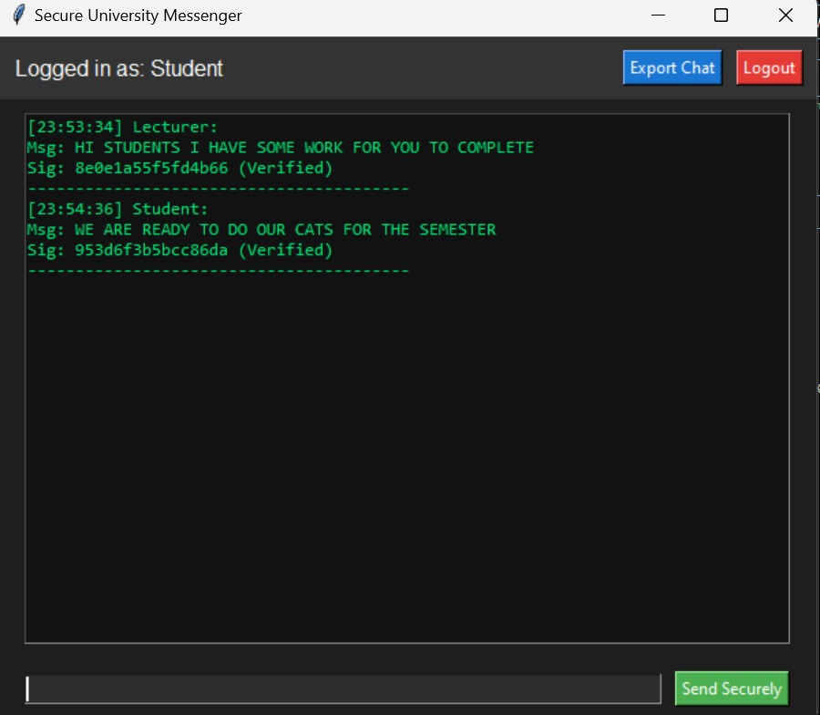
Figure 79 (The active chat screen): Secure University Messenger Chat Interface Displaying Messages and Digital Signatures
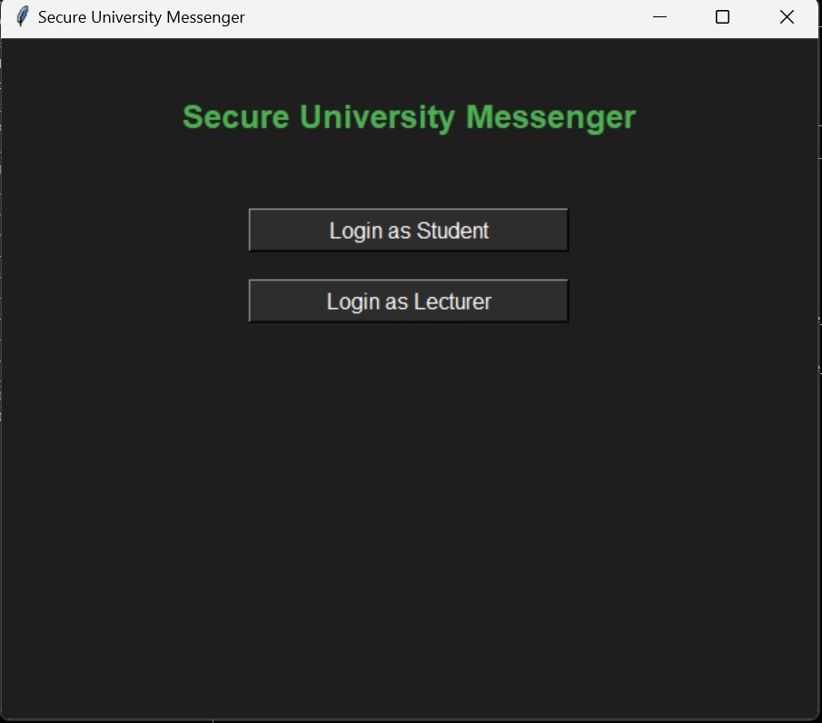
Figure 80 (The login screen): Secure University Messenger Role-Based Login Interface
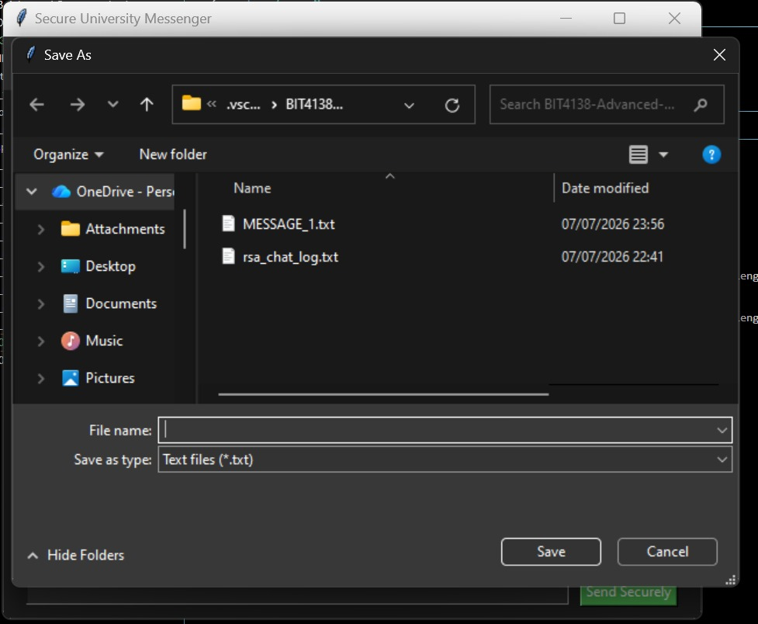
Figure 81 (The save dialog box): Secure Chat History Export Functionality to Local Text File
In Week 10, I developed a Python application implementing ElGamal and ECC to benchmark performance and demonstrate ephemeral key randomness. Additionally, I built the "Secure University Messenger," a dark-mode GUI supporting role-based logins, digital signature verification, and secure chat exportation, successfully fulfilling the interactive creative challenge.

Mini Project Extension: Cryptographic Architecture Evaluation
Prepared for: Kenyan Fintech Infrastructure Development
Topic: Public-Key Cryptosystem Recommendation (RSA vs. ElGamal vs. ECC)

1. Executive Summary
This report evaluates three dominant public-key cryptosystems—RSA, ElGamal, and Elliptic Curve Cryptography (ECC)—to determine the optimal architecture for a modern mobile fintech platform in Kenya. The evaluation considers the specific technical constraints of deploying digital financial solutions, focusing on lightweight requirements suitable for mobile-first user bases, M-Pesa API integrations, and secure peer-to-peer fund transfers.

2. Comparative Analysis
Evaluation Criteria | RSA | ElGamal | ECC
1. Security Level | High. Relies on the difficulty of large integer factorization. | High. Relies on the Discrete Logarithm Problem (DLP). | Highest per bit. Relies on the Elliptic Curve DLP. Extremely resilient.
2. Speed | Fast encryption & verification. Slow decryption & signing. | Slowest overall. Requires heavy modular exponentiations. | Fastest for signing and decryption using scalar multiplication.
3. Key Size | Large (2048+ bits required for modern security standards). | Large (2048+ bits required to prevent attacks). | Minimal (A 256-bit ECC key matches the security of a 3072-bit RSA key).
4. Memory Usage | High overhead due to large key storage and processing logic. | High overhead; ciphertexts are double the size of plaintexts. | Extremely Low. Ideal for constrained environments.

3. Suitability for Target Applications
- Mobile and IoT Suitability (5 & 6): Financial applications must run efficiently across a spectrum of devices, from low-end smartphones to basic USSD interfaces. RSA and ElGamal demand significant computational overhead, which drains mobile batteries and increases latency on cellular networks. ECC, with its highly compact 256-bit keys, generates minimal network payload and consumes negligible memory, making it the absolute gold standard for mobile and Internet of Things (IoT) point-of-sale integrations.
- Banking Applications (7): Modern digital financial solutions require rapid, continuous cryptographic handshakes for token signing and API authentication. ECC (specifically ECDSA) provides the computational speed necessary to process thousands of micro-transactions per second without bottlenecking server infrastructure. This is critical for high-volume banking gateways and integrations with telecommunication APIs.

4. Final Recommendation
For a modern Kenyan mobile fintech application, Elliptic Curve Cryptography (ECC) is the unequivocally recommended standard. It delivers the highest security-to-key-size ratio, strictly minimizing bandwidth costs, storage, and battery drain on user devices. Implementing ECC guarantees highly secure, high-speed API integrations while maintaining the rigorous cryptographic integrity demanded for real-time mobile money settlements and financial data protection.

